Homework – Half Term

This week please email homework to Miss Lee
This half term, why not spend some time reading in places all over whilst you explore with your family and friends. It might be tucked up in a cosy den in your bedroom or maybe at the beach whilst you have a day out. Take some pictures of these wonderful places you read in.
Maybe you could make some Valentines day crafts; if you put some shapes on one side of a heart using paint and then print it you can double the number! Why not try and see what it creates?
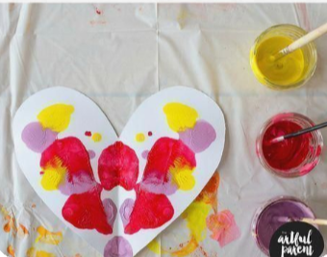

Why not visit Blackpool and see what human and physical features you can spot by the sea? Human features are man-made. Physical features are natural things that are part of our world.
TTRS/Numbots (Please access these as and when you can)
Year 2: please practice your 2’s, 5’s, 10’s, 3’s and 4 times tables on TTRS
Year 1: Numbots – please see username and password information in reading journals and do this every night (it will help with place value/number work.) Work your way through the levels and keep at it.
IDL: Logins will be in reading journals this week so that you can access 3 times a week at home.
Spellings
Please can you practice the common exception words for Spring for the appropriate year group you are in. Blue words are for Spring
