Homework – Friday 24th February

This week please email homework to Mrs Davis

Maths- Please spend time this weekend practising your 2’s, 5’s and 10’s times tables.
Reading- Continue to read your reading book daily and discuss key things such as characters, tricky spellings, the plot, the setting.
Topic – Please could you spend some time this weekend thinking of a name for our new class teddy bear. Maybe you could write the teddy a letter welcoming them to Parrots class.

TTRS/Numbots (Please access these as and when you can)
Year 2: please practice your 2’s, 5’s, 10’s, 3’s times tables on TTRS
Year 1: Numbots – please see username and password information in reading journals and do this every night (it will help with place value/number work.) Work your way through the levels and keep at it.
IDL: Logins will be in reading journals this week so that you can access 3 times a week at home.

Spellings

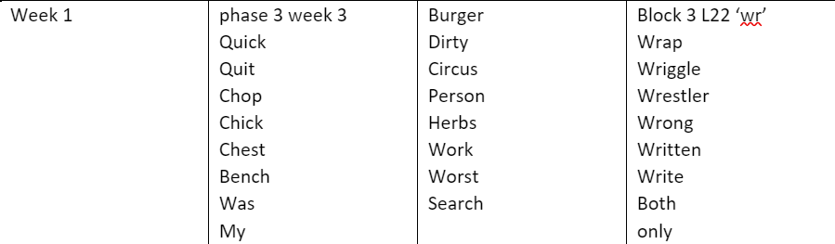
Group 1 Group 2 Group 3

