Homework – Friday 24th February

This week please email homework to Miss Lee

Maths- On Education City
Reading- I would like you to go on a noun hunt at home this weekend. How many different nouns can you spot? Maybe you could think of an adjective to describe the noun. For example, table…shiny table
Topic – Using a laptop/computer at home, please practice your typing skills. How do we make a capital letter? How do we put spaces in between our words? How do we enter down onto the next line? Maybe you could type up your nouns from the above activity.Can you search for something on the internet (please use Kiddle as this is a safe search engine) If you don’t have access to a laptop maybe look at a keyboard and point out these keys.

TTRS/Numbots (Please access these as and when you can)
Year 2: please practice your 2’s, 5’s, 10’s, 3’s times tables on TTRS
Year 1: Numbots – please see username and password information in reading journals and do this every night (it will help with place value/number work.) Work your way through the levels and keep at it.
IDL: Logins will be in reading journals this week so that you can access 3 times a week at home.

Spellings

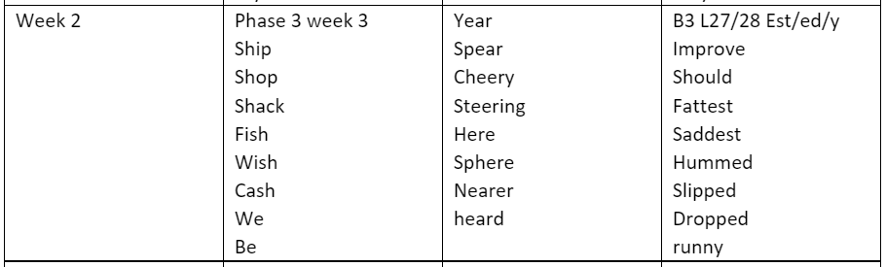 Group 1 Group 2 Group 3

