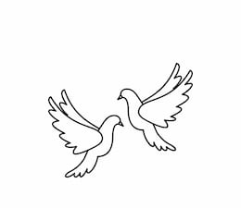
Friday 10th December 2021 Due: Wednesday 15th December 2021
Homework
Next week we will be making an Egyptian shaduf. Please can you bring an empty, clean yoghurt pot to school on Monday (13th).
We have had a brilliant week. We have enjoyed lots of Christmas activities. The children did amazingly well at the Elf Run. We have raised a wonderful amount of money. Thank you very much for your donations. We have also enjoyed recording our Christmas song in the local park. Don’t forget the Carol Service will go live next week.
Handwriting:
Practise writing your spelling words in neat, cursive handwriting.
Can you write each word in your own sentence.

Writing / Topic:
We have been learning about how to stay safe online. Please have a look at the following website.
https://beinternetlegends.withgoogle.com/en_uk?utm_source=google&utm_medium=cpc&utm_campaign=be_internet_legends&utm_term=beinternetlegends&gclid=EAIaIQobChMIsazwxezT9AIV7wOzAB3Xow22EAAYASAAEgIiD_D_BwE&gclsrc=aw.ds
Have a look at ‘Interland’ and have a go at some of the activities.
Can you tell a grown up how we can stay safe online?

Maths:
Complete the maths activity on Education City. This will link to all of the work we have done in maths this week.
Have a go at the times table quiz on
maths frame https://mathsframe.
co.uk/en/resources/resource/477/
Multiplication-Tables-Check

Complete the activity on Education City.

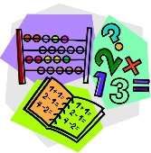
Christmas Dinner – School Lunch
Wednesday 15th December 2021
Please let the office know if you would like a Christmas dinner.

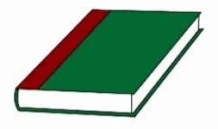
Reading:

