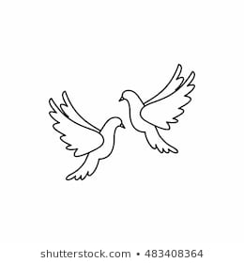**Friday11th March 2022** Due: Wednesday 16th March 2022

Homework

Handwriting:

Please practise your spelling words in neat, cursive handwriting.



Writing / Topic:

Read the following sentences.

How would you improve each sentence? Rewrite each sentence with your improvements.

The old man walked down the street.

It was a windy day. The black cat ran across the garden.

John tripped over a stick. The large ship sailed across the sea.



Maths:

Please complete the activities on Education City.

Continue using maths frame and TTRS to practise your times tables.

Please complete the reading task on Education City.

All library books need to be returned by Tuesday 16th March 2022.



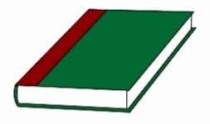Reading: