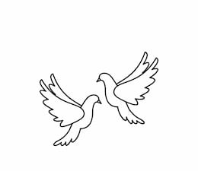
Friday 12th November 2021 Due: Wednesday 17th November 2021
Homework
Welcome back! I hope you all had a wonderful half term holiday. It has been lovely hearing about what the children have been getting up to. We have had a great week in Doves. On Tuesday, we had a brilliant visit from local author, Dan Worsley. The children were very lucky to spend the day with him. We learned so much and produced some amazing stories.
Dan Worsley is returning to school on Wednesday 17th November at 3.30pm. He will be in the Wing, signing copies of his brilliant books. KS2 children can purchase a book for £5 (cash only) or bring one of their own from home.
Handwriting:
Practise writing your spelling words in neat, cursive handwriting.
Can you write each word in your own sentence

Writing / Topic:
Next week is Anti-Bullying Week

Please can you think of three acts of kindness.
One for at home, one for at school and one in the community.
Why have you picked these acts?
Write down your ideas and be ready to share them in class next week.

Maths:
Complete the maths activity on Education City. This will link to all of the work we have done in maths this week.
Have a go at the times table quiz on maths frame https://mathsframe.co.uk/en/resources/resource/477/Multiplication-Tables-Check
Please continue to use IDL at home.
Please complete the reading task on Education City.

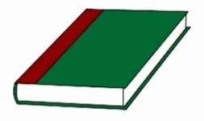
Reading:

Please return the trip permission slip by Monday 15th November 2021.

Please do not hesitate to come and see me if you would like to discuss anything about this week’s homework.
Miss Clarkson
e.clarkson@carletongreen.lancs.sch.uk

