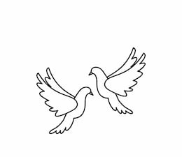
Friday 14th January 2022 Due: Wednesday 19th January 2022
Homework
This week we have been taking part in lots of reading activities. We have enjoyed writing a book review about our favourite book and we have been retelling the fantastic story, The Twits. We have also started our new class novel, Mr Stink.
Handwriting:
Practise writing your spelling words in neat, cursive handwriting.
Can you write each word in your own sentence.

Writing / Topic:
The Twits

Draw a sequence of pictures to retell the story of The Twits by Roald Dahl.

Maths:
Complete the maths activity on Education City. This will link to all of the work we have done in maths this week.
Have a go at the times table quiz on
maths frame https://mathsframe.
co.uk/en/resources/resource/477/
Multiplication-Tables-Check
Complete the prediction task on Education
City.

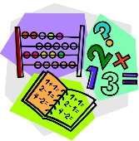
Wednesday 19th January – Where is your favourite place to read? Bring a photograph of you reading there ready for a new display.

Monday 17th January – Please bring your favourite book to school. Make sure it has your name in.

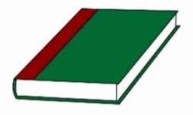
Reading:

