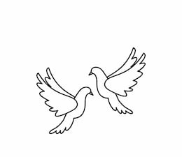
Friday 15th October 2021 Due: Wednesday 20th October 2021
Homework
It’s been a fantastic week in Doves. We have been enjoying our new maths topic and we have been learning about the pyramids. The children have been writing postcards and reading instructions. We have enjoyed editing and improving documents on a laptop and we have been writing our own poems linked to Tree Day. Thank you for coming to school in your green outfits, we have raised lots of money.
Handwriting:
Practise writing your spelling words in neat, cursive handwriting.
Writing / Topic:
Can you collect five interesting facts about the Pyramids.
You could write these on paper or create a word document to print or send to Miss Clarkson. Can you remember the tools we used on Word in our computing lesson?

Maths:
Complete the maths activity on Education City. This will link to all of the work we have done in maths this week.

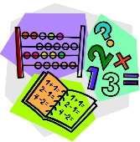

Parents Evening (online) Monday 18th and Tuesday 19th. Appointments can be booked online (see newsletter).

Reading:
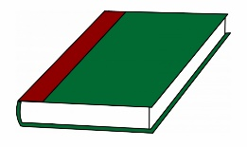
Continue to read at home.
Complete the reading task on Education City.

Please do not hesitate to come and see me if you would like to discuss anything about this week’s homework.
Miss Clarkson
e.clarkson@carletongreen.lancs.sch.uk

