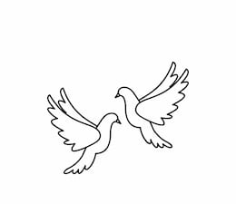
Friday 17th September 2021 Due: Wednesday 22nd September
Homework
Thank you so much for all of your incredible cake donations. We loved hosting Fairy Cake Friday this week.
This week we have been busy learning more about Ancient Egypt. We have been learning about the Egyptian Gods and finding out why Howard Carter was very important. We have started our new class text ‘The secrets of the Sun King’ and in Maths we have been partitioning three and four digit numbers.
Handwriting:
Practise writing your spelling words in neat, cursive handwriting.
Writing / Topic:
If you could ask Howard Carter questions about his amazing discovery, what would you ask him?
Write five questions.

Maths:
Complete the maths activity on Education City. This will link to all of the work we have done in maths this week.

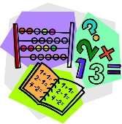

Reading:
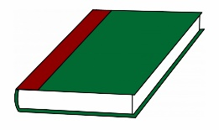
Complete the reading task on Education city.
Continue reading at home.
Don’t forget…
PE kit on Monday

Please do not hesitate to come and see me if you would like to discuss anything about this week’s homework.
Miss Clarkson
e.clarkson@carletongreen.lancs.sch.uk

