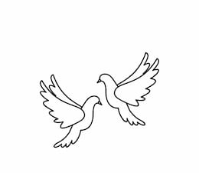
Friday 18th March 2022 Due: Wednesday 23rd March 2022
Homework
Next week we will be busy making illuminations as part of our DT. Please bring some cardboard to school. This needs to be thin, like a cereal box. Thank you.
Handwriting:
Please practise the common exception words in neat, cursive handwriting.
Writing / Topic:
This week we have been celebrating Science Week.

Can you carry out your own science experiment?
I would love to see photographs. Please send them via email.

Maths:
Please complete the activities on Education City.

Continue using maths frame and TTRS to practise your times tables.

If you have been given a script, please read and learn your lines.
You need to know all of your words off by heart.

Reminders: Mother’s Day event – Friday 25th March
LKS2 WOW Afternoon – Thursday 24th March 2.15pm
The new playground is for EYFS and KS1 children only. This should not be used before or after school.

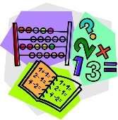

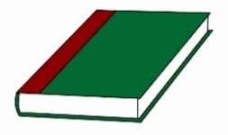
Reading:

