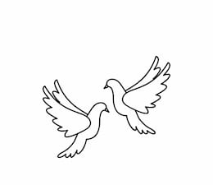
Friday 19th November 2021 Due: Wednesday 24th November 2021
Homework
Thank you to everyone who attended Dan Worsley’s book signing! It was lovely to see the children taking new books home. We have had a great week in Doves. It has been Anti – Bullying and Inter Faith Week. The children have been learning about different religions and we have been discussing ways to spread kindness. We have also enjoyed lots of science learning. We have been writing about Mary Anning and we have been investigating rocks.

Handwriting:
Practise writing your spelling words in neat, cursive handwriting.
Can you write each word in your own sentence

Writing / Topic:
We have really enjoyed learning about Mary Anning.
Next week we will be learning more about rocks and fossils.

For homework please can you research fossils and collect five interesting facts.

Maths:
Complete the maths activity on Education City. This will link to all of the work we have done in maths this week.
Have a go at the times table quiz on maths frame https://mathsframe.co.uk/en/resources/resource/477/Multiplication-Tables-Check

This week we have been making inferences using the evidence in a picture.

Please have a look at the image below. What can you infer? What
is happening? How do you know?
I know this because….

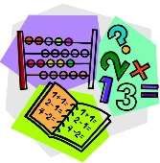

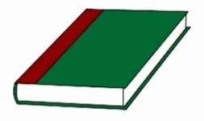
Reading:
Non Uniform Day
Friday 26th November
Please donate chocolate/sweets for the Christmas Market.

