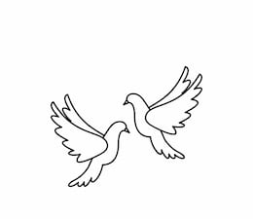
Friday 1st October 2021 Due: Wednesday 6th October 2021
Homework
We have had another busy week in Doves. We have started planning our own story, rounding numbers in Maths and we have been developing our French vocabulary. Please remember to bring some cardboard to school next week. The children will need an A4 size piece for their art project.
Handwriting:
Practise writing your spelling words in neat, cursive handwriting.
Writing / Topic:
This week we have been talking about recycling and the importance of reducing our waste.
Collect a list of ideas – what can we do to help?
Can you remember the 3 R’s?

Maths:
Complete the maths activity on Education City. This will link to all of the work we have done in maths this week.

Please continue using IDL and TTRS at home.
Reading:
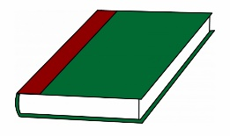
Continue to read at home.
Complete the reading task on Education City.

Please do not hesitate to come and see me if you would like to discuss anything about this week’s homework.
Miss Clarkson
e.clarkson@carletongreen.lancs.sch.uk

