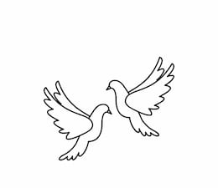
Friday 21st January 2022 Due: Wednesday 26th January 2022
Homework
This week we have enjoyed retelling the story of the Twits and we have been learning how to use the bus step method to help us solve division problems. Over the weekend please spend some time talking about road safety. What can you see on our roads to help you stay safe?
Handwriting:
Practise writing your spelling words in neat, cursive handwriting.
Can you write each word in your own sentence.

Writing / Topic:
Create a road safety poster. How do we stay safe? What can help us cross the roads?
Include pictures and clear safety instructions.

Maths:
Complete the maths activity on Education City. This will link to all of the work we have done in maths this week.
Have a go at the Battle on TT Rockstars.
We have created a competition for Owls,
Doves and Kestrels.

Please have a look at Oxford Owl and find a book to read and enjoy.
Username: cgdoves
Password: doves21

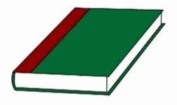
Reading:

