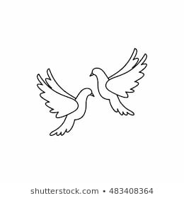**Friday 22nd October 2021** Due: Wednesday 8th November 2021

Homework

Practise writing your spelling words in neat, cursive handwriting.  
You could practise writing the following autumn and Halloween themed words.  
Make sure you also practise your common exception words.

Autumn, harvest, raincoat, puddles, pinecones, scarf

Halloween, cobwebs, pumpkin, horror, ghostly, skeleton  
Can you write a sentence for each word.

Handwriting:



Writing / Topic:

If you dress up for Halloween or go to a party you could write a diary entry to recount it.

If you go on an autumn walk, write a description. Describe all of the different things you can see, hear and smell. How is the park different in autumn to summer or winter?

Write a book review about a book you have read at home or one that an adult has read to you. Your job is to convince me to read it!



Maths:

Complete the maths activity on Education City. This will link to all of the work we have done in maths this week.  
  
In preparation for our multiplication topic next term please focus on practising your times tables. There are a lot of catchy songs on YouTube to help you.

Year 3 please focus on the 3s 4s or 8s. Year 4 please focus on 6s 7s and 12s

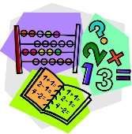

Reading: 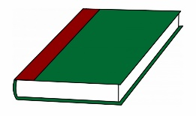

Our trip letter has been sent home.

Please return the slip by Monday 15th November 2021.

Continue to read your reading books at home.

Try to read a non – fiction book at home. Maybe you could visit the local library.

Please do not hesitate to come and see me if you would like to discuss anything about this week’s homework.

Miss Clarkson   
e.clarkson@carletongreen.lancs.sch.uk