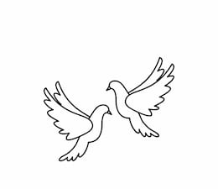
Friday 24th September 2021 Due: Wednesday 29th September
Homework
We have had another busy week in Doves. This week we have enjoyed learning French greetings. We met with Hawks class to have a conversation in French. We have started our new story writing topic and have enjoyed using adjectives to write descriptions. In Maths we have been finding more and less and learning about Roman Numerals.
Handwriting:
Practise writing your spelling words in neat, cursive handwriting.
Writing / Topic:
Create a noun phrase for each of the nouns below…
treasure tunnel pyramid mummy Egyptian God
Challenge: Write a sentence using your noun phrase
e.g. Silently, the explorer tiptoed through the secret, ancient tunnel.

Maths:
Complete the maths activity on Education City. This will link to all of the work we have done in maths this week.

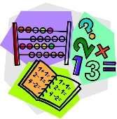
Please can you bring some cardboard to school for our upcoming Art project. We need A4 size pieces e.g. a cereal box by week 4th Oct.

Reading:
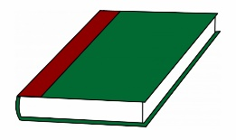
Continue to read at home.
Using your school reading book:
Make a list of words or phrases that have been used
to make sentences more interesting.

Please do not hesitate to come and see me if you would like to discuss anything about this week’s homework.
Miss Clarkson
e.clarkson@carletongreen.lancs.sch.uk

