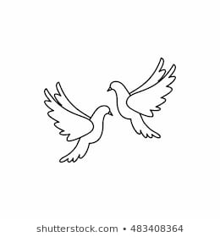**Friday25th February 2022** Due: Wednesday 2nd March 2022

Homework

Handwriting:

Please practise your spelling words in neat, cursive handwriting.



Writing / Topic:

As part of our RE topic we have been talking about what makes a good leader.

If you could be a leader, what would you like to be a leader of? What rules would you create?



Maths:

Please complete the activities on Education City.

Continue using maths frame and TTRS to practise your times tables.

It is World Book Day on Thursday.

In preparation, please can you think about some of the books you have read and enjoyed recently.

If you haven’t already done so, please email me a photo of you reading in your favourite place.

All library books need to be returned by Tuesday 1st March 2022.

**Reminders**: World Book Day – Dress as your favourite book character – Thursday 3rd March

Y4 Times Table Boosters begin – Monday 28th February



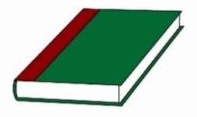Reading: