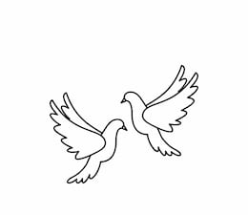
Friday 25th March 2022 Due: Wednesday 30th March 2022
Homework
COSTUME REMINDER: All costumes must be in school by Monday 28th March.
Handwriting:
Please practise the common exception words in neat, cursive handwriting.
Writing / Topic:
Please can you design a front cover for our performance programme.

This needs to be A5 size. We will be selecting some of our favourites to be printed on show days.

Make sure you include the title – Jill & Fred’s Most Hysterical Historical Adventure

Maths:
Please complete the activities on Education City.

Continue using maths frame and TTRS to practise your times tables.

Please read and learn your lines.
You need to know all of your words off by heart.
Practise reading and singing the songs.

Reminders: Mother’s Day event – Friday 25th March
Performance – Thurs 30th and Fri 31st 2pm
Friday 1st April – non-uniform £1
The new playground is for EYFS and KS1 children only. This should not be used before or after school.

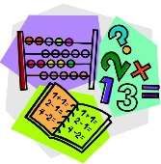

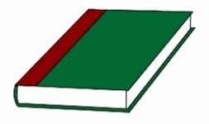
Reading:

