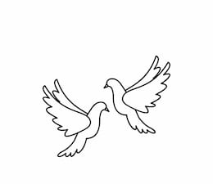
Friday 3rd December 2021 Due: Wednesday 8th December 2021
Homework
We had a wonderful Egyptian Day! Thank you so much for all of the effort you made! The children had a great day. We enjoyed marking Egyptian jewellery, dancing and mummy challenges.
Handwriting:
Practise writing your spelling words in neat, cursive handwriting.
Can you write each word in your own sentence.

Writing / Topic:
Next week we are going to be learning about newspapers and writing a newspaper article.

Please can you look at a newspaper and look at the different features that have been used.
How is the information presented? Is this the same on every page?

Maths:
Complete the maths activity on Education City. This will link to all of the work we have done in maths this week.
Have a go at the times table quiz on
maths frame https://mathsframe.
co.uk/en/resources/resource/477/
Multiplication-Tables-Check

Complete the activity on Education City.

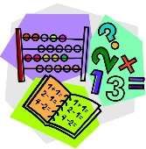
Please complete and return the new trip permission slip by Monday 6th December 2021.

We are hosting Fairy Cake Friday next week (10th Dec). Please can you bring some cakes for us to sell. Thank you in advance.

We are taking part in an Elf Run on Tuesday 7th December. Please come to school wearing PE kit for this event.
Christmas Jumper Day is on Friday 10th December.

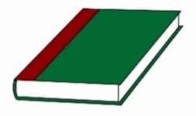
Reading:

