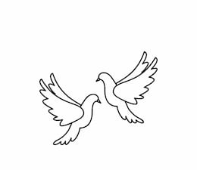
Friday 26th November 2021 Due: Wednesday 1st December 2021
Homework
We are having an Egyptian Day on Friday 3rd December. This will be to celebrate the end of our amazing topic.
If you would like to dress up for this special day you can come to school in Egyptian fancy dress. Please don’t worry about going out and buying a costume. You might like to come to school in a white t-shirt. We will be making Egyptian jewellery throughout the day or you could wear face paint in an Egyptian style.
Handwriting:
Practise writing your spelling words in neat, cursive handwriting.
Can you write each word in your own sentence.

Writing / Topic:
Next week we are going to be learning about diaries and writing our own diaries linked to our Ancient Egypt topic.
For homework please can you keep a diary for the next few days.
What does a diary include?

Maths:
Complete the maths activity on Education City. This will link to all of the work we have done in maths this week.
Have a go at the times table quiz on maths frame https://mathsframe.co.uk/en/resources/resource/477/Multiplication-Tables-Check

This week we have been reading, writing and performing poems.

Complete the activity on Education City.

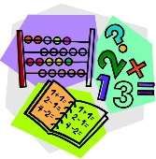

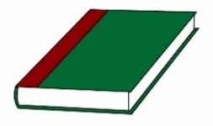
Reading:
Please complete and return the new trip permission slip by Monday 6th December 2021.

