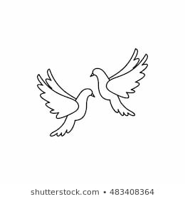**Friday28th January 2022** Due: Wednesday 2nd February 2022

Homework

Handwriting:

For spellings this week I would like you to spend some time practising your common exception words.

I would like you to choose eight words from your year group list (you can find these on a previous spelling sheet). Each day, choose a new set of eight words to practise. Please practise writing the words that you find most difficult to remember. Make sure the words are spelt correctly.



Writing / Topic:

**Big Garden Birdwatch weekend is here! There's still time to sign-up and take part. Just spend one hour between Friday 28 and Sunday 30 January counting the birds, and help monitor how birds are faring. It’s free, fun, and a great way to keep an eye on your local wildlife. Wherever you are, whatever you see, it counts!**

<https://www.rspb.org.uk/get-involved/activities/birdwatch/>

Please send me any photos of you taking part in the Birdwatch.



Maths:

.

Well done to those of you who took part in the TTRS competition. Kestrels were the winners!

The competition will continue for another week! Come on, Doves!

* We have also been learning about length. Can you practise measuring things around your home or garden? What unit of measure will you use? cm, mm or m?

This week we have enjoyed spending some time in our school library. All of the children have chosen a book that they would like to borrow. Enjoy reading them with your family.   
All books need to be returned Tuesday 9th February 2022.



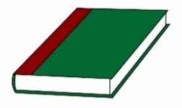Reading: