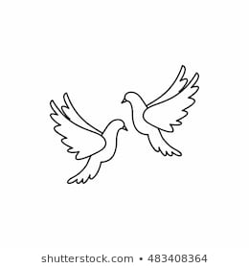**Friday4th February 2022** Due: Wednesday 9th February 2022

Homework

Handwriting:

Please practise your spelling words in neat, cursive handwriting.



Writing / Topic:

Next week Miss Lees will be collecting art work to take the Young Seasiders Art competition.

If you would like to create a piece of art (2D) please bring them to school by next Thursday (10th). The artwork can be anything you wish, be creative as you like.



Maths:

Please complete the activities on Education City.

Well done to those of you who took part in the TTRS competition. Kestrels were the winners!

Please log on to Oxford Owl and read a non -fiction and fiction book.

All library books need to be returned by Tuesday 9th February 2022.

**Dates to remember:** Parents Evening – Wednesday 9th and Thursday 10th  
Please book online using the link provided on email.

Non-uniform and crazy hair day – Friday 11th £1 donation

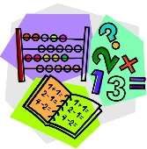

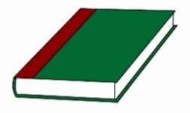Reading: