**Friday4th March 2022** Due: Wednesday 9th March 2022

Homework

Handwriting:

Please practise your spelling words in neat, cursive handwriting.



Writing / Topic:

This week we have been learning about the history of Blackpool.

Please design a poster persuading others to visit Blackpool.

What language will you need to use? What will persuade someone to visit?



Maths:

Please complete the activities on Education City.

Continue using maths frame and TTRS to practise your times tables.

We will be starting our rehearsals for our production very soon. In preparation, please think about whether you would like a speaking part. You will need to learn your lines off by heart for this role.

We will be holding auditions next week (Weds 9th, Thurs 10th and Fri 11th). Please let me know if you would like to audition.  
For the audition, please read the script on the following page and learn either Astrid or Ingrid’s part.

**Reminders**: Y4 Times Table Boosters – Doves – Tuesday 3.30-4.15pm  
If you can’t attend this session please ask for details of alternative dates and times.

All library books need to be returned by Tuesday 16th March 2022.



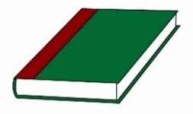Reading:

