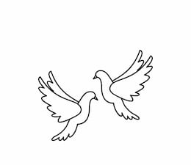
Friday 7th January 2022 Due: Wednesday 12th January 2022
Homework
Welcome Back! We had an amazing time on our school trip! Well done to all of the children for showing amazing behaviour around the museum. We had a wonderful time and enjoyed seeing some real mummies!
Handwriting:
Practise writing your spelling words in neat, cursive handwriting.
Can you write each word in your own sentence.

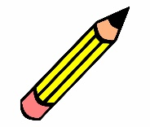
Writing / Topic:
Write a thank you letter to the museum or create a poster to encourage other people to visit.
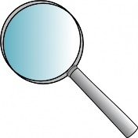

Maths:
Complete the maths activity on Education City. This will link to all of the work we have done in maths this week.
Have a go at the times table quiz on
maths frame https://mathsframe.
co.uk/en/resources/resource/477/
Multiplication-Tables-Check

Please have a think about the following questions

Discuss your answers with a grown up at home.
What is your favourite book? Why?
Who is your favourite author? Why?
Where is your favourite place to read?

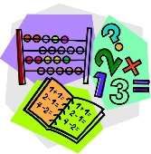
Please look out for a new competition starting next week.

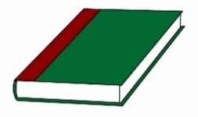
Reading:

