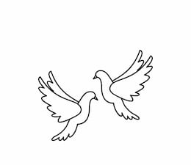
Friday 8th October 2021 Due: Wednesday 13th October 2021
Homework
We’ve had a fantastic week in Doves. The children have thoroughly enjoyed making their Egyptian death masks. They all look brilliant and will be going on display around school. We have also been extremely busy writing our own stories. I have been very impressed with the ideas that the children have developed.
Handwriting:
Practise writing your spelling words in neat, cursive handwriting.
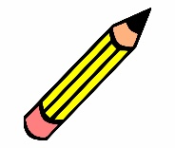
Writing / Topic:
Have a look at my list of verbs.
looked ran ate walked
Write an interesting sentence for each.
Challenge: Can you improve them? Can you include an adverb?

Maths:
Complete the maths activity on Education City. This will link to all of the work we have done in maths this week.

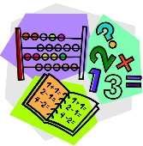

Parents Evening (online) Monday 18th and Tuesday 19th. Appointments can be booked online (see newsletter).

Reading:
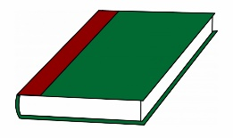
Continue to read at home.
Using a book of your choice can you make a list of
interesting verbs or adverbs that have been used.

Please do not hesitate to come and see me if you would like to discuss anything about this week’s homework.
Miss Clarkson
e.clarkson@carletongreen.lancs.sch.uk

