Homework – Friday 5th May

This week please email homework to Miss Lee
Maths- Education City
Reading – Think back to the Great Kapok tree story and pick 2 characters from the story. Write down how those characters might be feeling and use the words ‘because’ to tell me why they are feeling that way.
TTRS/Numbots (Please access these as and when you can)
Year 2: please practice your 2’s, 5’s, 10’s, 3’s times tables on TTRS
Year 1: Numbots – please see username and password information in reading journals and do this every night (it will help with place value/number work.) Work your way through the levels and keep at it.
IDL: Logins will be in reading journals this week so that you can access 3 times a week at home.

Spellings

Group 1 (ea) Group 2 (ure,ph) 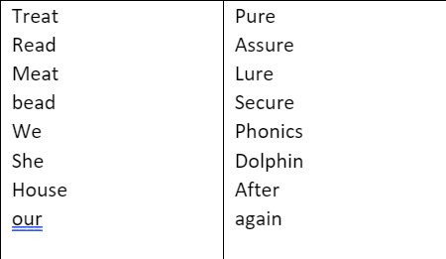
Group 3 (Year 2 children to practice common exception words)

