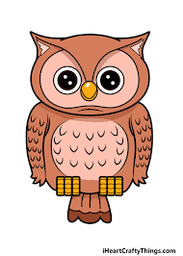
Homework
Due Friday 24th March
Please can all children keep practising their lines for the play.

English
- I would like you to design a programme for our upcoming play ‘Rock Bottom’. How you choose to create this is up to you. We will be choosing 4/5 designs to use as our official programme.
Reading
- Please read your school reading book or a book at home and fill in your reading record so I can see what you have been reading
- You can also log onto Oxford owl for additional books to read and activities to complete.
Username: cgowls
Password: owls21
Spelling

- Each week we learn a new spelling rule and then you will be tested on 8 spellings that follow this rule. You will also be tested on 2 random year 3/4 spelling list words. The weekly spellings can be found on Owls Home Learning Page. Please have a look at the spelling activities to help you with ideas to learn your spellings each week. *Please see updated spelling groups*
Maths
- Please complete maths sheet on mixed and improper fractions that we have been learning about over the last couple of weeks.

**IDL to be completed 3 times a week**
**Times Tables Rockstar’s to be completed 3 times a week**

