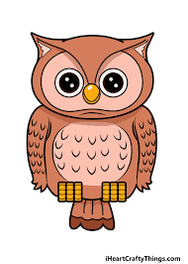
Homework
Due Friday 3rd February

https://www.rspb.org.uk/get-involved/activities/birdwatch

Big Garden Birdwatch long weekend is here! There's still time to sign-up and take part. Just spend one hour between Friday 27 and Sunday 29 January counting the birds, and help monitor how birds are faring. It's free, fun and a great way to keep an eye on your local wildlife. Wherever you are, whatever you see, it counts!

English
- We are having a focus on how we can reduce energy in school. The school council and Eco committee would like your ideas and I want you to create a poster to express your ideas. I will pick the most creative and informative poster from the class to display around school.
Reading
- Please read your school reading book or a book at home and fill in your reading record so I can see what you have been reading
- You can also log onto Oxford owl for additional books to read and activities to complete.
Username: cgowls
Password: owls21
Spelling

- Each week we learn a new spelling rule and then you will be tested on 8 spellings that follow this rule. You will also be tested on 2 random year 3/4 spelling list words. The weekly spellings can be found on Owls Home Learning Page. Please have a look at the spelling activities to help you with ideas to learn your spellings each week. *Please see updated spelling groups*
Maths
- Please complete the TTRS booklet you have brought home. This does not have to be completed in 1 week. Do a few each night.

**IDL to be completed 3 times a week**
**Times Tables Rockstar’s to be completed 3 times a week**

