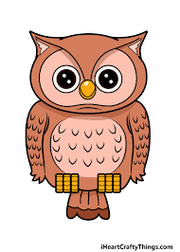
Homework
Due Friday 5th May

To celebrate the King’s coronation, we would like the children to design

their own crown and these can be worn on Friday 5th May. We will be

running a competition and there will be a winner from each class.

English
- Please see Education City
Reading
- Please read your school reading book or a book at home and fill in your reading record so I can see what you have been reading
- You can also log onto Oxford owl for additional books to read and activities to complete.
Username: cgowls
Password: owls21
Spelling

- Each week we learn a new spelling rule and then you will be tested on 8 spellings that follow this rule. You will also be tested on 2 random year 3/4 spelling list words. The weekly spellings can be found on Owls Home Learning Page. Please have a look at the spelling activities to help you with ideas to learn your spellings each week. *Please see updated spelling groups*
Maths
- Please see Education City.

**IDL to be completed 3 times a week**
**Times Tables Rockstar’s to be completed 3 times a week**

