Robin’s Homework
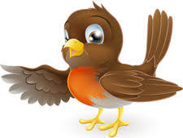
9th June 2023

Tasks
Please try and complete what you can . If you would like to email your work to me, my email is: c.clarke@carletongreen.lancs.sch.uk
Science: Can you create a poster on the theme ‘connections.
Examples such as - How about exploring how our body parts are all connected and work together, the connection between our actions and the impact on our environment, or even how internet connection has changed the world.
This is a competition and Mrs Catterall will be judging them next week.
Maths – Education City
Reading – Read your school reading book at home and ask a grown up to write in your reading record. Try and read a little bit every night.
You can always access Oxford Owl online for extra reading or read a book from home.
Times tables -
Y2’s - Times tables rockstars https://ttrockstars.com/beta/ Please practise your 2s, 5s and 10s.
Y1’s – Login to Numbots
IDL- Access IDL 3 times a week.
Spelling test will be every Friday
Spellings | Group 1 | Group 2 | Group 3
 | Fur, burn, hurt, turn, surf, curl, urn, with, them, then. | Knit, knot, knee, knife, know, knew, knight, gnat, gnash, sign. | Singing, kicking, licking, hoping, making, putting, swimming, shopping, stopping, clapping.

