Homework – Friday 1st December

Reading – Can you learn this poem and create actions- video it and email
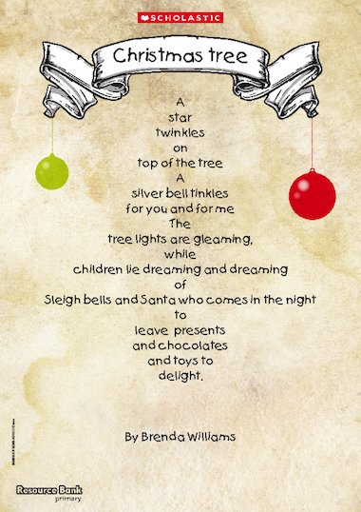
Topic – Can you write a letter to Santa? What would you like for Christmas? Time with your family? Snowball fights?
Maths – What 3D shapes might be under your tree this year? Can you guess what object/toy they might be? For example, a triangular prism might be a Toblerone.
PLEASE CAN YOU PRACTICE NATIVITY LINES/SONGS
IDL: 3 x a week
TTRS/Numbots
Spellings
Year 1:
the, said, me, by, you, she, your, we, they, there
Year 2:
door, told, every, water, everybody, class, again, after, could, fast
Reminders:
Costumes in

This week please email the homework to Miss Lee;
k.lee@carletongreen.lancs.sch.uk

