Playscripts | Write a chosen myth as a playscript | Science  Common animals
Explanation | Science-What's in our garden?  Common plants and parts | Science  Compare and identify common animals | Art  Texture and form sculpture (clay) | DT  Food
Poetry | Science  Compare and identify common animals  RE
Non-Chronological Report | History  The Building of Blackpool Tower  Travel and Transport | Geography  Skills and fieldwork
Narratives -Myths | Science  Common animals

Stunning Starter: Wild Discovery – Ribby Hall Visit
Fantastic Finish: Animal themed day- making animal masks, dressing up as an animal, painting clay models

Sticky Learning
Instructions – Making fruit animals
Geography- continents and oceans
Poetry- shape poems
Explanation – What is needed in a healthy lunchbox

Instructions – programming with bee-bots

Enrichment:
Healthy Living Week – WB 23rd May
Queen’s Jubilee-
Music Day- 21st June
Transition week – WB 11th July

Texts
Fiction | Non-Fiction | Poetry
Tinga Tinga Tales  Jungle Book  How The Elephant Got His Trunk (Collins Big Cat)  How the tiger got his stripes (Collins Big Cat))  The Hunter by Paul Geraty | The Variety of Life by Nicola Davis and Lorna Scobie  Creature Features by Natasha Durley | Pie Corbett Animal Poems  www.teachprimary.com

English – Cross-Curricular Writing
- Genres
  - Playscripts
  - Explanation
  - Poetry
  - Non-Chronological Report
  - Narratives - Myths

Year 1
Spell words containing the 40+ phonemes, common exception words
Add suffix –s and –es to create plural nouns/third person singular for verbs
Use prefix –un
Form correctly oriented lower case letters, capital letters and digits
Leave spaces between words
Use punctuation for sentences using capital letters, full stop, question mark and exclamation mark
Use and to join words and clauses
Use capital letters for names of people, places and days of the week
Use vocab from stories eg myths to increase vocab in their own writing
Understand how language can be used in narrative and non-fiction
Say out loud what they’re going to write about
Compose sentences orally before writing
Re-read what they have written to make sure it makes sense
Discuss what they have written with the teacher/pupil
Become familiar with and retell key stories, fairy stories and traditional tales
Recognise and join in with predictable phrases and use in writing
Sequence sentences to form short narratives

Year 2
Learn alternative spelling phonemes
Spell CEW, contractions and homophones
Use the possessive apostrophe
Add suffixes -ment, -ness, -ful, -less, -ly
Form lower case letters of correct size and proportion
Start using diagonal/horizontal strokes to join and know which are best left unjoined
Write capital letters of the right size, orientation, and proportion
Use correct spacing between letters and words
Write from memory simple sentences dictated by the teacher
Use commas in lists
Use sentences with different forms
Use expanded noun phrases
Use present and past tense
Use subordination and use co-ordination when, if, that, because or, and, but
Use features of standard english
Use simple recurring literary language in stories and poems
Discuss and clarify meanings of new words
Use drama and role-play to identify with and explore characters
Draw on a wide range of stories, poems and plays and information books

English - Reading
Year 1
Become familiar with and retell key stories
Join in with predictable phrases
Recite some poems/rhymes by heart
Discuss meanings of new words/vocab provided
Self-check to make sure text makes sense
Discuss significance of titles/events
Predict and infer based on what they know and the text
Take turns to explain their understanding
Retrieve and record information from non-fiction
Take turns in high-quality discussions about what they have heard/read
Apply phonic knowledge to decode
Respond with correct sound to graphemes for all 40+ phonemes
Read words with contractions and understand role of apostrophe
Read aloud accurately books that are consistent with taught phonics

Year 2
Discuss sequence of events in books
Discuss and clarify meaning of new words/phrases
Continue to learn/present poems by heart
Self-check to make sure text makes sense
Make predictions and inferences
Ask and answer questions
Participate in discussions about texts, explaining their understanding
Retrieve and record information from non-fiction
Take turns in high-quality discussions about what they have heard/read
Continue to apply phonic knowledge to decode until reading is fluent
Read accurately by blending sounds, recognising alternative sounds for graphemes
Read words containing common suffixes
Read further common exception words

Maths
Time
To use time & ordering vocabulary.
To tell the time to the hour and half-hour.
To use language for the days, weeks, months & years.
To tell time to the nearest 5 minutes including quarter to/past.
To compare and sequence intervals of time.
Measure
To use common vocabulary for comparison, e.g. heavier, taller, full, longest, quickest.
To measure and record length, capacity, weight.
To know and use standard measures.
To read scales to nearest whole unit.
To compare and order measures using < or >.
Position and Direction
To describe position & movement, including half, quarter and three-quarter turns.
To use terminology for position & movement.
Problem Solving
To solve problems involving measure/time.
To solve reasoning problems.
Recap and consolidation
Addition, subtraction, multiplication and division
Place Value
Money
Fractions
Property of shape

PE
Fundamental Movement Skills: Throwing and catching, striking
participate in team game
begin to develop simple tactics for attacking and defending
Identify how to improve in different physical activities
Practise basic movements including running, jumping, throwing and catching
Develop simple tactics for attacking and defending
Participate in team games following simple rules
Discuss how to improve in different physical activities

Dance
Perform simple dances
Perform dances using simple movement patterns
Discuss own performances
Evaluate own and others' performances

Athletics
Master basic movements including running, jumping, throwing and catching
Practise basic movements including running, jumping, throwing and catching
Develop and apply agility and co-ordination
Identify how to improve in different physical activities
Discuss how to improve in different physical activities

Geography
Location Knowledge
Look at the local area before and after the building of Blackpool tower Y1– at this point in the year make comparisons by using tables or as a report depending on ability.

Y2 - at this point in the year make comparisons by writing a report either by using a teacher provided framework or more independently.

Place knowledge
Consider how the town developed after the building of the tower – accounts by those living at the time if available would be useful. Children can use a framework to write a simple report.

Children write a more detailed report and some may be able to structure it themselves.

Human and Physical Geography

Consider human geography which is more of a focus here – how man has changed the look of the landscape and how this affected both jobs and tourism.

Y1 - Again this can be linked to a labelling activity or a simple, teacher structured report.

Y2 - Again this can be linked to report writing.

Geographical Skills and Fieldwork

Children will find out about their environment by looking at photos, film footage and considering accounts of those alive at the time.

Create simple map with key and symbols with some support.

Create simple map with key and symbols independently.
1 | I can recognise human and physical features of Blackpool.  I understand what Blackpool is like.  Contact Miss Lee’s friend who is a family member of Sir John Bickestaffe.
Children to look at a range of images of Blackpool before and after the building of the Tower.
https://historicengland.org.uk/images-books/publications/blackpools-seaside-heritage/blackpools-seaside-heritage/
https://www.blackpoolgrand.co.uk/blackpool-tower-built
https://www.dailymail.co.uk/news/article-6984245/Never-seen-shots-Blackpool-Tower-built-125-years-ago.html
https://www.theblackpooltower.com/history/the-tower/

Consider how the town developed after the building of the tower – accounts by those living at the time: get in touch with Miss Lee’s friend who is a family member of Sir John Bickestaffe.

Children to report their findings in tables showing their understanding of human and physical features before and after the tower was built.

2 | I use arial photographs to identify human and physical features of Blackpool.  I understand what Blackpool is like.
Children to have arial photographs of Blackpool before and after the building of the Tower and identify human and physical features in all and compare with the photographs they looked at in the previous lesson.

https://www.oldmapsonline.org/en/Blackpool
https://www.yannickdixon.com/blackpool/aerial-photographs-of-blackpool/
https://earth.google.com/web/@53.81789266,-3.01765982,7.76838781a,3422.83635192d,35y,0.17711519h,0.10527696t,-0r/data=CkwaShJECiUweDQ4N2I0MTE3ZTk0MmQwMTc6MHhiNTJkYjIxNzkyMzJjMmM5GUHnfwOk6EpAIapUmt4PSQjAKglCbGFja3Bvb2wYAiAB

Children to report their findings in tables, progressing on to a detailed written report showing their understanding of how Blackpool looked before the tower was build and after using the photographs and images from this lesson and the previous lesson. Children to include about, both human and physical features.

3 | I understand basic geographical features surrounding Blackpool Tower (human features). ( Computing Session 5 & 6 design a mat for Beebot links to B’pool)  I understand different types of buildings in Blackpool.  Children to bring in photographs of them in Blackpool to display and discuss. If they have any family members of them in Blackpool when they were younger they could be emailed or sent in. Please look after them.
Consider human geography which is more of a focus here – how man has changed the look of the landscape and how this affected both jobs and tourism.

Have a look at the holiday resort in the late 1800s to early 1900s:
https://school-learningzone.co.uk/key_stage_one/ks1_geography/the_seaside/the_seaside.html
https://www.youtube.com/watch?v=wiG4uDr998c
Children to share and discuss family members in Blackpool.

Have a look at the holiday resort now:
https://www.visitblackpool.com/detail/blackpool-beach-275980/
Children to share their images of them in Blackpool, can they compare and contrast to the previous ones?

https://localhistories.org/a-history-of-blackpool/

Record findings of human geography (landmarks, houses, recognise building types, etc) as a holiday resort then and now in tables and move on to a more detailed report. Children to show they understand how jobs and tourism has affected these changes.

4 | I can use maps to gather information about Blackpool. (Links to Computing session 5&6)  I can recognise map symbols.
Locate key places and landmarks on maps and describe the location of key places accurately including Blackpool Tower.
Use different maps and understand the key features.

https://earth.google.com/web/@53.81789266,-3.01765982,7.76838781a,3422.83635192d,35y,0.17711519h,0.10527696t,-0r/data=CkwaShJECiUweDQ4N2I0MTE3ZTk0MmQwMTc6MHhiNTJkYjIxNzkyMzJjMmM5GUHnfwOk6EpAIapUmt4PSQjAKglCbGFja3Bvb2wYAiAB

http://www.towncentremap.co.uk/england/blackpool.html

https://www.streetmap.co.uk/

https://www.orangesmile.com/travelguide/blackpool/high-resolution-maps.htm

https://www.bbc.co.uk/teach/class-clips-video/geography-ks1--ks2-maps/zdwhpg8

https://www.bbc.co.uk/bitesize/topics/zqj3n9q/articles/zjd66v4

Children to show their understanding of the key places of Blackpool and map symbols by creating their own map of Blackpool.

5 | I can use simple compass directions (N, S,,E,W), locational and directional language. (Computing session 3 –direction)  I can use maps to gather information about Blackpool.
Links to computing.

Sticky learning: remind the children of the work they did with directional language when learning about the Lake District.

https://www.youtube.com/watch?v=Te0Td0QVoj0

Create a map of Blackpool for their Beetbot which the children need to direct using N, S, E, W.

6 | I can make comparisons of different places.  I can compare Blackpool over time.
Links to history: 2 and 3.

Remind the children of the different maps and images they have looked at during the topic so far.
Show the children a range of different ones they have not seen use images of transport. Name and describe different types of transport. Begin to understand transport was different when their parents and grandparents were little. Children to understand that transport: cars, buses, trains have changed over time.
Children to write a non-chron report about how different places and transport in Blackpool have changed.

7 | I can use simple fieldwork and observational skills to study the area of Blackpool Tower.  I can observe what Blackpool is like.  I can use simple compass directions (N,S,,E,W). (Computing Session 3)
Children will find out about their environment by going to look at the Blackpool Tower, looking at photos, film footage and considering accounts of those alive at the time.
Plot a simple route on a map using simple compass directions N, S, E, W. (Computing session 3)
Children to a non-chron report about what Blackpool is like.
8 | I can use simple fieldwork and observational skills to study the surrounding environment of Blackpool Tower.  I can observe what Blackpool Tower is like.  I can use simple compass directions (N,S,,E,W) (Computing session 3)
Linked to history.

Explore geographical issues surrounding the Tower through discussions. Look at this over time and what issues there have been. Recap over tourism and what issues this has brought for the tower.

Class teachers to use the following issues but to adapt for KS1:

https://www.lancs.live/news/lancashire-news/real-sources-pollution-blackpools-beaches-17702789
https://www.blackpoolgazette.co.uk/news/environmental-issues-could-halt-hovercraft-plans-1269297
https://www.theguardian.com/environment/2016/oct/13/the-eus-effect-on-blackpools-beaches-before-and-after-pictures

Children to create a table then a detailed report about the issues Blackpool face.

9 | I can recognise how people can affect the surrounding environment of Blackpool Tower.
Look at last lesson to then build on how people affect this. Remind the children that Blackpool is a seaside resort where people enjoy visiting. Why does this affect an area?

Class teachers to adapt these examples to KS1 and to suit Blackpool Tower: https://www.bbc.co.uk/bitesize/guides/zqk7hyc/revision/3

10 | I can use a range of presentational skills.
Children to present to their peers about all they have found out about Blackpool before the tower and currently. The children need to draw up on their history too. They are to show they understand many changes and issues Blackpool Tower’s surrounding area face. They are to express own views and opinions about the environment and suggest simple improvements.
Children to use images, tables and parts of their non-chron reports.

History
Chronology
- Place key people and events on a timeline. (building of the tower and other significant events)
- Identifying some similarities and differences between ways of life in different periods.

Key people & Dates
- Use simple stories and other sources to show that they know and understand key features of events.
- Place key people and events on a timeline.
- Recall the names of and some key information about significant individuals from time of study (architects, mayor, attractions etc.).
Changes over time
- To tell the difference between past and present in their own and other people’s lives by using and making simple comparisons to parts of stories, and features of events.
- Recognise that their own lives are different from the lives of people in the past by describing some of the topics, events, and people that they have studied.
Use of sources
- Use sources to answer simple questions about the past.
- Know and recount episodes from stories about the past.
- Ask and answer questions about the past through observing and handling a range of sources, such as objects, pictures, people talking about their past, buildings, written sources.
- Describe memories of key events in lives using source material and the experience of people.
Communicating findings
- To show what they know and understand about the past in different ways (speaking, role-play, drawing and writing).

1 | I can find out and recall facts about Blackpool Tower.
Use Blackpool Tower website https://www.theblackpooltower.com/history/the-tower/ to read about the history of the Tower and some of key facts about the building of it.
Children to create a poster/fact file about the Tower and some of the key facts and figures about the structure being built.

2 | I can identify similarities and differences between life in the past and present (Blackpool Tower)
Links for Geography session 6 & 8

Look at photos of the building of Blackpool Tower (see document in KS1 Teams) and discuss the similarities and differences between the Tower during it’s construction and the present day. Make comment on the clothes that the construction workers are wearing and how it differs from today.

Children to produce a differences and similarities table. This can be done in groups or individually.
3 | I can recognise that my life is different from the lives of people in the past
Links to Geography session 6
Watch this https://www.youtube.com/watch?v=S-mxBB9gSpk Discuss the differences between the images of Blackpool and how life has changed over time.

Children to write a short explanation (sticky learning) explaining how their life is different to people in the past
4 | I can place key events on a timeline.
Look at https://blackpoolheritage.com/tours/history-of-our-tramway/ and read through the information about the history of the trams. Discuss how the design of the trams has changed over time and also the size of them.
Also this https://www.liveblackpool.info/about/trams/blackpool-trams/ and https://blackpoolheritage.com/our-fleet/ which may be of use.

Children to produce their own timeline of the history of the trams.
5 | I can ask and answer questions about the past.
 | Get in touch with Miss Lee’s friend (member of Sir John Bickerstaffe’s family). Children to generate questions that they would like to ask about the building of the Tower and his importance in the building of the Tower.
6 | I can recognise how my life is different to the past.
Children to be aware of how the tram line is developing and being extended to link up to the train station. Use this website for information and also some informative videos https://www.liveblackpool.info/about/town-centre/blackpool-tramway-extension/

Discuss views and opinions about these changes. Is it a good thing to be changing and why and what are is the impact on the town centre with these changes.

Link to geography and the change in human geography over time.

7 & 8 | I can show what I have understood about the past
 | Using the knowledge gained so far, children to produce a short non-chron about the history of Blackpool Tower and its transport. Ch’n can present this how they wish eg double page spread in their book/PowerPoint/ leaflet. Encourage ch’n to draw upon their geographical knowledge that they have gained during this topic.

RE
Christianity
Talk about what is meant to belong to a family
Talk about the role of families in raising children
Identify features of baptism – e.g. The font, candles, godparents
Talk about why parents might want to have their child baptised
Know that some Christians welcome babies into the God’s family (the Church) with baptism ceremonies
Talk about what it might mean to belong to the church family
Talk about their own identity as part of a family and part of the school community

Judaism
Notice and show curiosity about people and how they live their lives (finding out about Jewish festivals – thinking about the fact that people celebrate different celebrations in very different ways e.g. Sukkot)
Notice that for many people, trust is an important part of human life
Use some religious words and phrases to recognise and name features of religious traditions (e.g. Sukkot, Festival)
Talk about the way that religious beliefs might influence the way a person behaves (e.g. like Noah and Abraham, Jewish people should trust that God keeps his promises)
Give an example of a key belief (ie that Jews believe in one God) and/or a religious story (the story of Noah and/or Abraham)
Give an example of a core value or commitment (trusting that God will keep his promise)
Ask questions (about the importance of trust and who they can trust/rely on in their own lives)

1  Christianity | I can talk about what it means to belong to a family and the role of families in raising children
Ask children and staff to bring in photographs of their families to share with the class. Talk about who is in their family. Identify the different relationships that the children may have within their families e.g. brother/sister, son/daughter, cousin.
What makes a family? How does a family look after children.
Write an acrostic poem using the word Family.
2 | I know that Christians welcome babies into God’s family with Baptism ceremonies  I can talk about what it might mean to belong to the Church family
Talk about why Christian parents may decide that they want to have their baby baptised. Christians believe that the Church community is like a family. Remind children that they have previously found out that Christians think of God as being like a father.
In some Christian communities, parents ask for their child to be baptised so that it can belong to this family and can develop a relationship with God. They believe that this will mean the baby will grow up with the support of the Church family as well as their own family. Watch a video of an infant baptism https://www.youtube.com/watch?v=hysJSb38mCQ (watch from 1:50 to 5:10)
Write a non-chronological report on a Baptism
3 | I can identify features of a Baptism  I can explain why parents might want to have their child baptised
https://www.youtube.com/watch?v=hysJSb38mCQ (watch from 1:50 to 4:40) rewatch the video Identify who is involved in the baptism and what is used. Talk about the cross that is made on a baby’s head in the context of welcoming a child into the family of God in the church. Ask them what the cross symbolises. Take a virtual tour of a church and locate the font at http://e4education.uk-virtualtours.co.uk/church/
Label and describe features of a baptism using a picture e.g. https://www.twinkl.co.uk/resource/t-re-463-ks1-baptism-labelling-activity-sheet
4 | I can talk about my identify as part of a family and school community
Talk to children about family. Can we be part of wider communities outside out immediate family? E.g. school, church, hobbies, clubs, friendships
Put photographs/drawings of the children in the centre of flower outlines (https://www.kindpng.com/picc/m/139-1397370_black-flower-outline-flower-black-and-white-hd.png). On the petals children can record what they belong to through writing or drawing.

5  Judaism | I can explain how trust is an important part of life  I can ask questions about the importance of trust and identify who I can rely on.
Circle time - discuss the importance of promises. Ask the children to give examples of promises that they have made within the class. E.g. I promise I will not hit, I promise I’ll wait my turn. Ask why it is important we can trust one another to keep these promises – why is it important to be trustworthy? What makes someone trustworthy?
Make a class promise and decorate with fingerprints as signatures. Display the promise/s on the wall (We will come back to this in lesson 10)
6 | I can talk about the way that religious beliefs might influence the way a person behaves  I can use religious words and phrases to explain religious traditions
Watch Temima explaining her faith to her friend: https://www.bbc.co.uk/teach/school-radio/assemblies-ks1-ks2-judaism-jewish-culture-festivals/zhrmwnb
Write a non chronological report detailing some of the features of the Jewish faith (Key vocabulary: Torah, synagogue, mezuzah, shabbat)
7 | I understand how people celebrate religious celebrations differently (Sukkot)  I can use religious words and phrases to explain religious traditions
Watch Jumpin’ Jerusalem- Sukkot https://www.youtube.com/watch?v=h_W1pGtlRsY
Talk about how the celebration of the Sukkot is similar/different to the celebrations some people celebrate each year? Encourage children to understand that celebrations are important in many cultures as a way of remembering something special and often as a reminder to be grateful – in the same way, Sukkot is a time for the Jews to remember to be grateful to God for keeping his promise and providing them with all that they need.
Children to write an explanation of what the Jewish celebration Sukkot

8 | I can give an example of a Jewish belief and a story related to it
 | Shared read: https://www.tes.com/teaching-resource/the-story-of-noah-s-ark-for-ks1-6089047 Noah’s Arc – talk about the story and how this impacts the way Jewish people live their lives. Children write a narrative retelling the story of Noah’s Ark (2 lessons)
9 | I can give an example of a core Jewish value or commitment  I can talk about the way that religious beliefs might influence the way a person behaves
Shared read: https://www.twinkl.co.uk/resource/t-re-476-ks1-abraham-and-isaac-story-powerpoint
What we can learn from Abraham is that his focus was on God's power to fulfill his promises and not on the circumstances he was facing. Abraham knew that God was willing and able to keep every promise he made to him.
10 | I can explain how trust is an important part of life  I can ask questions about the importance of trust and identify who I can rely on.
 | Reflection: Look back at the class promises – discuss if they have been kept by all members of the class, do they feel that they will be able to continue to keep these promises throughout the rest of the year, how easy/difficult is it to keep promises?

Science
Plants (Y1)
- identify and name a variety of common wild and garden plants, including deciduous and evergreen trees
- identify and describe the basic structure of a variety of common flowering plants, including trees
- observe and describe how seeds and bulbs grow into mature plants
- find out and describe how plants need water, light and a suitable temperature to grow and stay healthy

Animals, including humans (Y2)
- notice that animals, including humans, have offspring which grow into adults
- find out about and describe the basic needs of animals, including humans, for survival (water, food and air)
- describe the importance for humans of exercise, eating the right amounts of different types of food, and hygiene

1 | I can identify and name a variety of common wild and garden plants.  I can identify and name a variety of deciduous and evergreen trees.  Mrs Hicks to be in this lesson.
What is in our garden?
Children to have an A4 piece of paper to draw their garden and label their common plants, flowers and trees. Do they have a vegetable patch? Do they have a greenhouse? What do they grow?

Show the children a range of different types of plants and flowers in class before going outside to identify them. Children to add to their garden drawings if they can identity other plants and trees in their own garden.

As a class take a walk around the school garden (KS2 field, EYFS garden and near the wing) and identify what common garden plants and trees there are. Ask Mrs Hicks to join you on the tour so she can explain what has been planted and why. Children on the walk around to know the names of deciduous and evergreen trees.
For the start of the Working Wall, as a class, create a large floor map of the school grounds and children to identify and name common and wild garden plants and deciduous and evergreen trees.

2 | I can identify and name a variety of common wild and garden plants, including deciduous and evergreen trees.  I can identify and describe the basic structure of a variety of common flowering plants, including trees.  I can observe and describe how seeds grow.  Mrs Hicks to be in this lesson.
Ask the chn to sit in groups and to look at the different potatoes. Ask them if they know what they are and have seen them in this raw form before. Draw a large potato outline on the board and ask each group to offer facts and experiences about potatoes for you to write inside the large drawing. Encourage statements such as 'chips are made out of potatoes, we grow them at home, they grow in the ground' etc. Ask them if they can also list the different things we do with potatoes and write these on the large drawing (e.g. mashed potato, chips, shepherd's pie, crisps). Show the chn the potato masher and explain how to make mashed potatoes. Ask any adults in the room to cut up the different potatoes for the chn to see inside and to smell. Give them time to do this, explaining that different sorts of potatoes are used for different things. Some make better mash whilst others make really good chips. Ask the groups to describe the differences and similarities between the different varieties.
Then explain that the chn we have grown chitted potato plants from seed potatoes and we need to learn how to look after them (Mrs Hicks to show the children and explain how they have gone from a seed to chitted potatoes). Children to learn that the nature of the potato flower and seed is such that the pollination produces seed with very different features. Young children just need to know that the chitted potatoes or tubers are ‘seed potatoes.’ Children will know what potatoes need to grow.
https://www.rhs.org.uk/education-learning/gardening-children-schools/family-activities/grow-it/grow/chit-early-potatoes
https://www.youtube.com/watch?v=G8kYhHxS0ag
3 | I can identify and name a variety of common wild and garden plants, including deciduous and evergreen trees.  I can identify and describe the basic structure of a variety of common flowering plants, including trees.  I can observe and describe how seeds and grow.  I can find out and describe how plants and trees need water, light and a suitable temperature to grow and stay healthy.  Possible walk to the Plant Place.  Prior to this lesson, all children to bring in a photograph of their garden (it could be a grandparents/aunties etc) to display in class.
Ask the look at all the different gardens displayed around the classroom (sent in by each other). Ask children to identify the different gardens they like, why? What plants and trees can they spot? What can they see growing? Explain that all gardens are different - different shapes, locations, climate, plants and design. Then ask if they have been to a garden centre before. Play them https://www.youtube.com/watch?v=F2lJW7TaF18, typical of many garden centres in the UK or possibly visit The Plant Place. Children will understand what a garden is and how varied they are.

Bring them together and tell them that they are going to grow a bean plant from a bean seed in a freezer bag. Once finished, peg onto a washing line. Ask each child to predict what they think will happen to the bean. Give them a ‘bean in a bag diary’ ask them to fill in the first section about what they have done and then complete the diary as it grows.

What have you noticed about our beans? What is missing from our bean growing, that we definitely had when the potatoes were planted? (Soil.) Do you think the bean seeds will grow? What have they got that is the same as the seed potatoes? (Water, warmth.) Children will plant a seed in a bag and consider what it needs to be able to grow and predict the outcomes of the bean sees and set up a diary to observe the growth over time.

https://www.youtube.com/watch?v=EKx4ZwoJqXY
4 | I can identify and name a variety of common wild and garden plants, including deciduous and evergreen trees.  I can identify and describe the basic structure of a variety of common flowering plants, including trees.  I can observe and describe how seeds and bulbs grow into mature plants.  I can find out and describe how plants and trees need water, light and a suitable temperature to grow and stay healthy.  Mrs HIcks to be in this lesson.
Take the chn outside to find flowering plants in the school grounds. Give the chn a magnifying glass and ask them to look closely at the flowers. Ask them to describe what they see and compare them, spotting the similarities and differences. Mrs Hicks to teach the children different flower names. Children will be able to examine the flowers with a magnifying glass and become familiar with the inside of a flower.
https://www.youtube.com/watch?v=bLhTgTwbYMI
Then take the chn back into the class and let them look at the flowers on the tables. Ask them to share what they see, encouraging the use of ambitious adjectives and descriptive language. Then allow them to choose a flower, with stem, each and gently pull it apart, laying all the pieces of it on the white paper. Write these words on the board: 'stem', 'roots', 'leaves' and 'flower'. Ask the chn to have a go at writing the right words on the white paper next to the right parts. The cut flowers won't have roots but the chn could draw roots on the paper. Children to understand why roots are needed.
Chn to work in groups to make a model of a flower plant using junk modelling materials. Encourage the groups to think carefully about the shape of each part they want to create, perhaps using strips of paper for the roots, tubes for the stem, etc.. Allow the chn some time to paint their junk models in the week. Children to have their flowers displayed as a garden and label the parts and functions. Children will understand the basic structure of a flowering plant and the function of the main parts.
5 | I can identify and name a variety of common wild and garden plants, including deciduous and evergreen trees.  I can identify and describe the basic structure of a variety of common flowering plants, including trees.  I can find out and describe how plants and trees need water, light and a suitable temperature to grow and stay healthy.  Collect leaves of deciduous and evergreen trees, pieces of bark and logs for the lesson.  Mrs HIcks to be in this lesson.
Show the chn images of evergreen and deciduous trees. Talk about trees the chn are familiar with, in their gardens or the playground. Remind them of the working wall. Do they lose their leaves in the winter? Can you remember? Do they stay green all year round? If we don't know, can we guess by looking at the shape of their leaves? Are they evergreen or deciduous?
Go into the playground and count how many deciduous and evergreen trees there are outside. If possible, look closely at a deciduous and evergreen tree, and take wax crayon rubbings of the bark and leaves. Children will be able to discuss and become familiar with the similarities and differences between evergreen and deciduous trees,

Look at the floor map on the working wall to remind the class of the common wild and garden plants along with deciduous and evergreen trees.
Children to start the lesson outside by going back outside and looking at the different types of trees. Children to complete small tree rubbings and label each rubbing with the different type of tree name. Children to know the different types of trees.
https://www.woodlandtrust.org.uk/blog/2019/11/tree-bark-crafts/
When back inside look carefully at the bark and logs. Ask the chn to do wax rubbings and to explore the textures in front of them. Make sure they use the long, flat side of the wax crayon.

Show the chn how to measure the girth of a tree. Give them chalk to write the girth size in cm on the ground near the tree. Then move on to measuring the height of the trees. Make a note of these measurements in case you want to measure the trees again later on in the year. Tell them the tree must have five things: roots - to hold the tree in the ground so that the wind cannot blow over it and so it can take water from the soil; bark - the skin of a tree; a trunk - the strongest part of the tree and takes water from the roots to the leaves; branches - has leaves, flowers, or fruit growing on them and leaves - they make the food for the tree and also evaporate water which helps to keep the surface of the leaf cool. Children will have an awareness of the role of the: roots, bark, trunk, branches and leaves of a tree.

http://dryproject.co.uk/wp-content/uploads/2014/11/School-activity-with-Key-Stage-1.pdf

6 | I can identify and name a variety of common wild and garden plants, including deciduous and evergreen trees.  I can describe the importance for humans of exercise, eating the right amounts of different types of food.  Letters to be sent to parents for permission of taste testing!
Links to DT lesson of making fruit animals. This can be taught together.

Ask the chn to sit in groups and to look at the (whole) fruit and vegetables on the tables. Ask them if they recognise any of them and if they know anyone who grows them, remind them of the first few lessons. Give the chn some time to discuss together and share ideas about the fruit and vegetables. Encourage questions such as: What sort of plant does this grow on? Would this be an easy thing to grow? How much water do you think it would need? How long do you think it would take to grow? Ask the chn to feel and smell the fruit and veg. Ask them to guess what they look like inside. Ask the adults to go to the groups and to cut open the different fruits and vegetables.

Make sure all the groups have an adult supervising them then invite the chn to try a little piece of the fruit or vegetable. Encourage the use of ambitious adjectives and descriptive phrases. Say to the chn: We are going to draw the food that you can see, but not in the usual way we might draw an apple or a carrot. We are going to be drawing in a very special way. We will be pretending that we are tiny people and we are looking really closely at a piece of fruit or vegetable. Can you imagine that? Can you look closely at a section of the food? Look really closely, as if you were tiny. Does it have hairs? Or little droplets of juice? Or bumps? Can you draw that view in your sketchbooks? Show chn the resource with the close-up images of fruit. These images concentrate on a small section or slice and look carefully at its colour and structure. Take close-up photographs of these fruits and vegetables to display later, along with the drawings and images of their fruit animals.

7 | I can describe the importance for humans of exercise, eating the right amounts of different types of food, and hygiene.  Liaise with kitchen and letters to be sent to parents to explain they will need a packed lunch to include: bread, cheeses, fruits and vegetables (ensure you have more vegetables than other foods) and other packages foods which are suitable for lunchboxes.
Links to PSHE and PE, this is to be taught in healthy living week. PSHE 5 and 6.

Organise a class picnic. Children to have their lunch altogether either in class or outside. Children to have a photograph with their packed lunch box which includes a range of: fruit/vegetables, carbohydrates, protein etc

On a large piece of paper in the middle of the floor, draw an example of a lunch box in sections and ask the children to talk about what they have to eat in the different sections, starting with what is probably the easiest to recognise: the fruit. Together, name the fruits they all have. Then, together, add the vegetables. Explain that carbs is short for carbohydrates and includes the usual lunch box items of bread, pasta, rice or potatoes. Name the different ones they all have in this section. Tell the children that protein is mainly the lunch box items of cheese, meat, eggs or milk. Fill this section up using the protein sample foods. Together look at the large lunch box. Ask: What do you notice? Which section is biggest (vegetables)? Are you surprised? Which section were you expecting to have the most food in? What do we now know about keeping our lunch boxes healthy? (More vegetables than other things, small amounts of snack and fruit, smaller, equal amounts of protein and carbs.) Children will be able to explore different lunch box foods and understand the different categories.

Children to design their own lunch boxes and also to begin to look at the packaged foods. Ask them to explore the nutritional labels; ask them: Which foods have the most sugar? The most fats? Which have the least? Can you order them? Those children who have lunch boxes in school may want to design a lunch box mat which fits inside the bottom of their actual lunch boxes to remind them of what a balanced lunch can look like. Children will begin to understand what is meant by a balanced lunch.

https://www.foodafactoflife.org.uk/5-7-years/healthy-eating/interactive-resources/
8 | I can describe the importance for humans of exercise, eating the right amounts of different types of food, and hygiene.  I can find out about and describe the basic needs of animals, including humans, for survival (water, food and air).
Links to PE. PE to be taught before or alongside this lesson. PSHE 5 and 6.

Set out different PE equipment in a carousel (minimum of 4 activities). Half need to be designed to get the heart pumping hard (for example, hoops on the floor to jump in and out of, cones to sprint between, low level hurdle to jump over, star jumps.) The other activities need to be calmer so the heart can slow down and recover (for example, walking with a beanbag balanced on the head, keeping a ball between the knees and walking between two cones).

Play this clip to them about the major organs of the body: http://www.bbc.co.uk/education/clips/zswn39q. Explain that they are going to do different tests to find out what effect exercise has on their heart. Ask them to feel their heart whilst they are just sitting still and before exercise. Make sure they have their hand on their heart and not their stomachs! You may wish to teach children to take their pulse via their neck or their wrist. See http://www.cyh.com/HealthTopics/HealthTopicDetailsKids.aspx?p=335&np=285&id=1467#1 for a guide on this. Start a minute timer (on the IWB or an egg timer) and ask them to count quietly to themselves to see how many beats of their heart they can feel. Then show them the two elastic bands. Show them the one at room temperature and show them how it stretches without breaking. Then show them the elastic band that has been in the freezer. It should break when you stretch it. Explain that our muscles are like elastic bands and get damaged when we exercise without warming them up. Ask them to stand up and do your usual PE warm up routine. Then place the children in PE partners, give them a clipboard each and a table to record pulse rate and a timer per pair. Tell them they are to work together to fill their own sheets in as they move around the carousel activities in the PE space. Children will understand that exercise makes the heart work and that warming up before exercise is important. Children will know that some exercise makes their heart-beat fast and some slows it down. Children to understand that they can observe changes and record data in a simple table.

Play this clip to the children, explaining the role of the heart in the body: http://www.aboutkidshealth.ca/en/justforkids/body/pages/heart.aspx. What kinds of exercise do you enjoy doing? What exercise can you do outside school?

9 | I can notice that animals, including humans, have offspring which grow into adults.  I can find out about and describe the basic needs of animals, including humans, for survival (water, food and air).  Egg-hatching. Need to wait for the school incubator and eggs. Record a time lapse if the children are unable to see the hatching and play for this lesson.
Children to sort and name the stages in human life: baby ◊ toddler ◊ child ◊ teenager ◊ adult • Discuss differences between stages e.g What are the differences between toddlers and babies?
https://www.bbc.co.uk/bitesize/clips/z8x76sg
In small groups children to match the adults to their babies: kitten > cat, puppy > dog, duckling > duck, chick > hen/chicken, calf > cow, piglet > pig, lamb > sheep, tadpole > frog, caterpillar > pupa > butterfly
A baby ___ is called a ____.
How are you different from a toddler? What is similar about a kitten and a cat? What is different? How do animals’ (including humans) needs change as they grow up?

What do you think is in the egg? What do you think it looks like? Give them some time to think about it and ask them to draw what they think. Do you think the inside of the egg has changed over the last few weeks? When it first came out of the hen/duck, what do you think was inside the egg? Show the chn the stages development. Spend some time dwelling on the stage that the classroom eggs are at. Now we know what is actually happening inside the egg, how do we feel about our quick drawings? Have we been surprised by anything? Would we change anything? When the eggs start to hatch, make sure the chn are positioned around so that everyone can see without knocking the eggs. Stress the importance of remaining quiet and calm. Ask the chn to watch carefully, take photos/videos. Encourage them to talk about what they can see: Can you see the beak? The egg tooth? What does it sound like? Can you hear the chirping of the new chick? What do you think the chick will look like or behave like when it is out of the egg? Is anyone surprised by what they are seeing? Children will understand the development of a chick in an egg and then how a chick grows into a hen/duck. Children will observe hatching chicks closely and record what they see, hear, smell and feel.

Play the chn at least a few minutes of this 7 minute clip showing older chicks eating, drinking and interacting with each other: https://www.youtube.com/watch?v=JbRGUECyGas.

Explain to the chn that the newly-hatched chicks will look like this in a couple of weeks. Ask the chn to observe them, looking at what they are eating (corn) and drinking (water) and how they are behaving (running around, pecking each other). What do you think chicks need to grow into adults, into hens? (The right food, water, warmth, clean place to live.)

10 | I can identify and name a variety of common wild and garden plants, including deciduous and evergreen trees.  I can notice that animals, including humans, have offspring which grow into adults.  I can find out about and describe the basic needs of animals, including humans, for survival (water, food and air).
Children to have a range of images of different animals and different sorting opportunities on different tables and rotate. Use a range of Venn and Carroll diagrams to sort. 1) can fly, cannot fly, 2) has legs, can fly, has fur or hair, 3) can fly, cannot fly, has two legs, has more than two legs etc

Children to have a range of animals with different parts for children to label, for example: pig, horse, fish. Discuss the different features. Why does a fish have a fin? Why does a horse have a mane? Ensure children know it is because they need to adapt to where they live and it enables them to survive.

Children to be shown a range of habitats: mountain, sea, forest, desert, polar, river, beach, jungle and savannah. Discuss the different features of the habitats they can see: colours, weather, plants, trees etc.
Children to match up a range of pictures of animals to the different habitats then go through together as a class.

Children to know the following features of the different habitats: plants (flowering/non-flowering), weather, animal names, colours, herbivores, carnivore and omnivore.

Children to understand that animals and their habitats have different features to enable the animals to have the basic needs to survive,

11 | I can identify and name a variety of common wild and garden plants, including deciduous and evergreen trees.  I can notice that animals, including humans, have offspring which grow into adults.  I can find out about and describe the basic needs of animals, including humans, for survival (water, food and air).
Child initiated learning: from the previous lesson decide as a class which two different habitats and different animals you are going to study in dept to compare. Looking at similarities and differences.

What are the features of the habitats? Why? What are the adult animals called? What are the young called? What do the animals need to survive in their habitat?

Children to know the following features of the different habitats: plants (flowering/non-flowering), weather, animal names, colours, herbivores, carnivore and omnivore. Children to know the names of two different habitats with different animals (knowing the adult and young names) and understanding the basic needs of the animals are to survive.

PE
Fundamental Movement Skills: Throwing and catching, striking
participate in team game
begin to develop simple tactics for attacking and defending
Identify how to improve in different physical activities
Practise basic movements including running, jumping, throwing and catching
Develop simple tactics for attacking and defending
Participate in team games following simple rules
Discuss how to improve in different physical activities

Dance
Perform simple dances
Perform dances using simple movement patterns
Discuss own performances
Evaluate own and others' performances

Athletics
Master basic movements including running, jumping, throwing and catching
Practise basic movements including running, jumping, throwing and catching
Develop and apply agility and co-ordination
Identify how to improve in different physical activities
Discuss how to improve in different physical activities

1 | Perform simple dances
 | Practise basic movements including running, jumping, throwing and catching
2 | Perform dances using simple movement patterns
 | Begin to develop simple tactics for attacking and defending
3 | Perform dances using simple movement patterns
 | Participate in team games following simple rules
4 | Perform dances using simple movement patterns
 | participate in team game
5 | Discuss own performances
 | Develop simple tactics for attacking and defending
6 | Evaluate own and others' performances
 | Identify how to improve in different physical activities
1
 | Practise basic movements including running, jumping, throwing and catching
2
 | Develop and apply agility and co-ordination
3
 | Master basic movements including running, jumping, throwing and catching
4
 | Identify how to improve in different physical activities
5

6
 | Discuss how to improve in different physical activities

Music
Y1
Change and combine sounds when creating music.
Begin to explore their feelings about music using movement, dance and expressive language
Identify silence and sounds that are loud and quiet and the differences between fast and slow speeds
Understand how sounds can be made in different ways and described using given invented signs and symbols
Y2
Explore a variety of vocal qualities through singing and speaking.
Change and combine sounds when creating music. (Making use of pattern and using the different dimensions of music to create contrast)
Offer comments about own and other’s work – ways to improve/accept feedback.
Begin to use onomatopoeia sound words to describe selected sounds and the ways in which they are pronounced.
Recognise the difference between a steady beat and not beat and identify sections within a piece of music which sound the same or different.

1 | I can listen, respond to, and learn about the works of The Carnival of the Animals.  I understand what tempo means.
Listen to this https://www.youtube.com/watch?v=vCHDS_a_4Ms - Film trailer – Charlotte´s Web. Explain that we hear classical music all the time in TV programmes, films etc. In Charlotte’s Web there is a piece of music called ‘Aquarium’ the composer that wrote this is called Camille Saint-Saens. Ask children to explain what a composer is/does. Tell them that Saint-Saens then went on to write a suite of music about animals including, fossils, Kangaroos, Lions etc. Play this https://www.youtube.com/watch?v=r52dbwr5ZSc - Introduction music (only 30 seconds). Count to 8 and clap at the same time, keeping a steady beat. Imagine how these animals move. Which animals might have a slow, steady beat? Is the elephant big or small? How does it move? It is big and moves slowly so the music has a steady beat. Recap pitch and tempo.
Chn to work in groups. Give each group a sheet of A3 paper and pictures of a selection of animals. Sort the animals by tempo (fast & slow). Chn can stick the animals underneath the correct tempo, and then write short description next to the animal, e.g. The Elephant is slow and steady.
2 | I can listen with concentration and understanding to a range of high quality live and recorded music  I can create a listening map to a piece of music.
Explain to children that an orchestra is made up of different sections and instruments and Saint-Saens uses an orchestra for these compositions. Can children name any instruments from an orchestra? Use these clips below and discuss the name of the instrument, which section they are from in the orchestra and how they are played (bowed, blown or struck)
http://www.soundsnap.com/tags/violin - Violin (strings) clip
http://www.soundsnap.com/search/audio/clarinet+sample/score - Clarinet (woodwind) clip
http://www.soundsnap.com/search/audio/drum+kit/score - Drum (percussion) clip
http://www.soundsnap.com/search/audio/trumpet/score - Trumpet (brass) clip.
Discuss the role of the conductor too. Play https://www.youtube.com/watch?v=jkn8u2JwCPI - Benjamin Britten´s Young person´s guide to the Orchestra, a shorter version with audio cues. Split the class into 4 sections and teacher to be the conductor. Encourage children to listen for cues for their section so they know when to come in and mime their part.
Play the Finale https://www.youtube.com/watch?v=FPwqWgltUDo (2.10) Discuss the instruments.
Play the music again, give out A4 paper and ask chn to create listening maps (see below) to the music. Label and colour their pictures.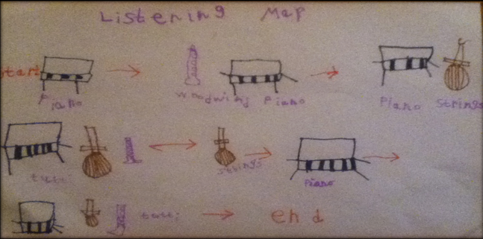
3 | I can understand how sounds can be made in different ways through tempo and dynamics.  I can play a pitched instrument.
Listen to The Kangaroo from Carnival of the Animals https://www.youtube.com/watch?v=Lu0zLxzV2Jc Can the children guess what the animal might be based on what they hear? Why? What is the tempo? Is the music staccato (disjointed) or legato (joined and smooth)? Encourage the children to describe what’s happening to the dynamics and the melody rises and falls. Use the listening map below to follow the rise and fall of the melody as you replay the music.
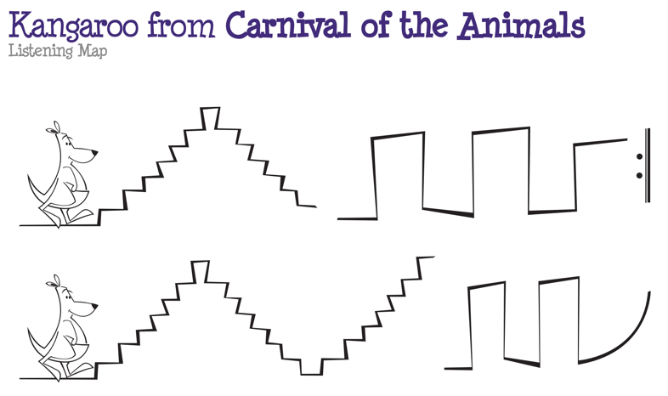
Use Glockenspiels and let the children explore playing ascending and descending major 2nd patterns. Can they change the tempo and dynamics too?
Children could also make their own Kangaroo music on glockenspiels practise leaping from note to note. Plan which notes you are going to jump from and land on plan and practise quiet, gentle landings.

4 | I can change and combine sounds when making music.
Listen to Aquarium from Carnival of the Animals https://www.youtube.com/watch?v=IyFpZ5MZ7kk Don’t show them any images related to the video. Can the children guess what animal might be based on this music?

A gentle and mysterious tune on the violins is accompanied by patterns on the piano sounding like ripples on water.

Pupils could collaborate to make a graphic score (see image) suggesting fish in an aquarium consider quick, darting movements of small fish near the surface graceful, flowing movements of Angel fish swimming in the middle depths sluggish, slow-moving fish patrolling the depths of the aquarium.

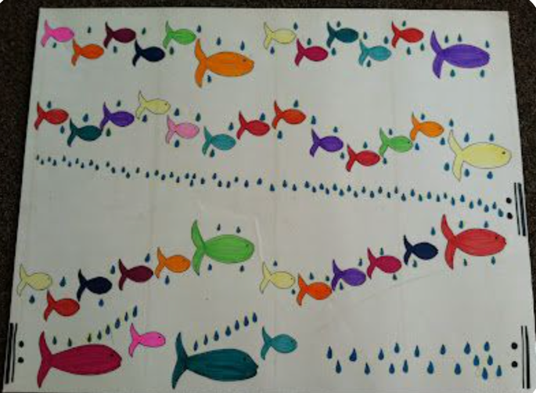
The levels might suggest high, middle and low-pitched sounds, played at different speeds to reflect the movements of the fish. Use a screen saver of fish to aid observations as to how fish move.
5 | I can keep a steady beat.  I can identify sections within music.
Listen to the music Fossils: https://www.youtube.com/watch?v=WhAUjEgRHXg Get children to tap a steady pulse on their legs to match the music. Listen to the piece a few times until children feel confident with the speed of the music and begin to recognise the main section that keeps returning. The pattern in the picture below matches the repeating section of “Fossils”.

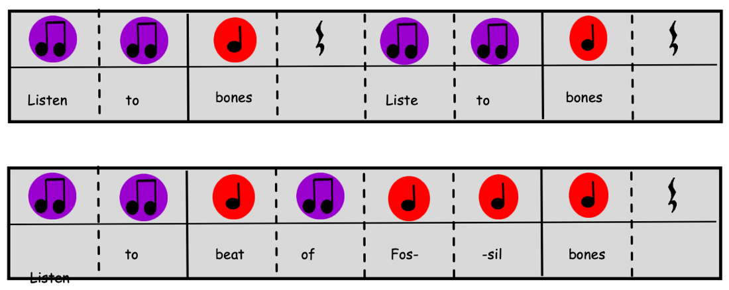

1. Practise saying the words to the rhythm pattern.
(Remember that the purple notes are quick and worth half a beat, while the red notes are 1 beat. If there is an empty block, take a rest for 1 beat.)
2. Practise clapping the rhythm pattern while saying the words in your head.
3. Get a plastic bowl and 2 plastic spoons or make a craft stick xylophone, or a paper xylophone, (which you can make with this video clip: https://www.youtube.com/watch?v=KxQOJja9XVM ), or anything else on which you can bang).
Perform the rhythm on your new xylophone.
6 | I can listen to and respond to a piece of music.
Listen to Camille Saint-Sains Carnival of the Animals https://www.youtube.com/watch?app=desktop&v=1L993HNAa8M . Pick out different animals by using the markers in the video and pictures of the animals on the screen.

Children to create their own sounds like Saint-Seans for animals. Use the worksheet (in Music resources folder in KS1 Teams) to help choose an animal, describe the animal, choose if the music should be loud or soft, fast or slow, smooth or short choppy sounds. Children could record your sounds on a device.

7 | I can use my voice expressively and creatively by singing songs, speaking chants and rhymes and adding vocal sound effects.  I can experiment with, create and combine sounds using the inter-related dimensions of music.
Learn and Sing “Down in the jungle”– https://youtu.be/K1fZHoqdH-E -

Explore making rhythmic vocal animal sounds. - Rehearse and then perform a simple chant/ rap about walking in the jungle using rhythmical animal noises that the children have created.

8 | I can use my voice expressively and creatively by singing songs, speaking chants and rhymes and adding vocal sound effects.  I can use a range of tuned and untuned percussion instruments to experiment with, create and combine sounds using the inter-related dimensions of music.
Watch the Bitesize clip about adding instrumental and vocal sounds to a story about the rainforest. http://www.bbc.co.uk/education/clips/z26b9j6

Watch the Bitesize clip about adding instrumental and vocal sounds to a story about the rainforest. http://www.bbc.co.uk/education/clips/z26b9j6 Explain to the children that the children will be making some musical stories about various animals. - Explore the different timbres of a selection of tuned and untuned instruments. - in small groups of 5 or 6 children add vocal and instrumental sounds using voice, body percussion and a selection of tuned and untuned instruments thinking about timbre, dynamics, pitch, and tempo.

Art
I can Use correct artistic vocabulary texture, details, mark making.
. I can use a range of pencils to draw lines of different lengths/ thickness and show pattern using dots and lines
Know about the work of a range of artists, craft makers and designers
n painting, use a variety of thick and thin brushes to produce lines and shapes, textures and patterns
In sculpture, use techniques such as rolling, cutting, moulding, and carving
Talk about the work of an artist, craft maker or designer.

I can Describe differences and similarities and make links to own work

How do the artist achieve a desired outcome?
Describe differences and similarities and make links to own work. What improvements could they make before their final piece?
In sculpture, create and combine shapes to make recognisable shapes

Use and apply art and design techniques in using colour, patterns, texture, line, shape, form and space with range of materials

1 | .I can Use correct artistic vocabulary texture, details, mark making.
create a mark making page in sketchbooks. Explain and explore
How can different techniques create different effects. Can you create different effects when using the same medium? For example, all the marks made below are made using a pencil. They all look different and show different textures. We can create different textures and depths by changing the shape and density of the mark we are making. We can change the mark made by adding pressure.
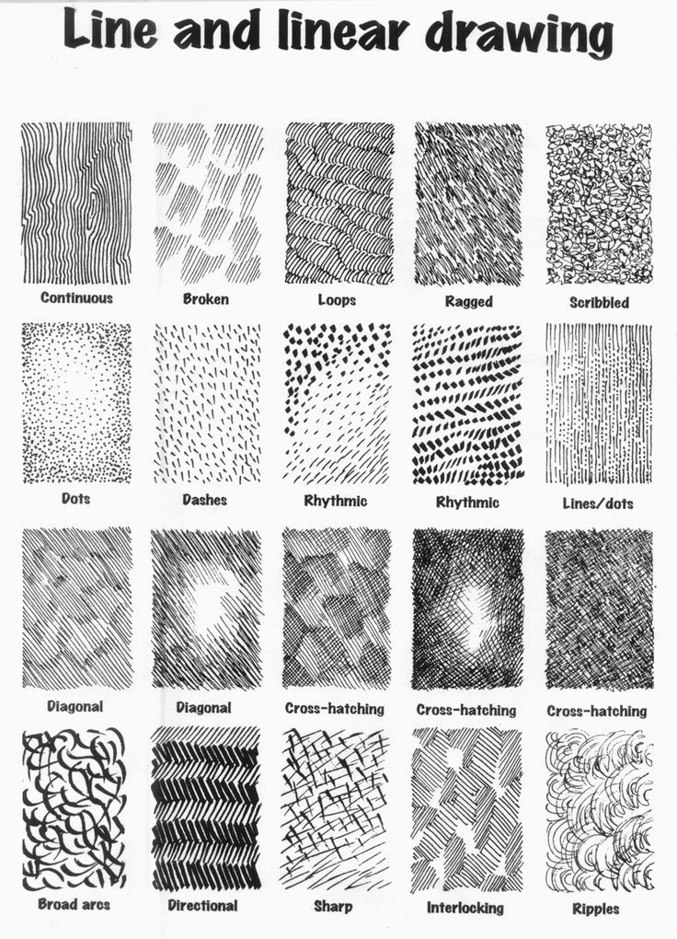

2 | . I can use a range of pencils to draw lines of different lengths/ thickness and show pattern using dots and lines
Look at artist that create art from dots/lines- mark making. To link with carving patterns, adding dots or lines. Pointillism/ line art. Key aspects of sculpture and form. To explore the 3D element using depth and tone.
Create a drawing in the style of a pointillism artist. The children will have to think about tone and texture. The children may want to create this of a plant, succulent, or flower. To add details using pointillism style. 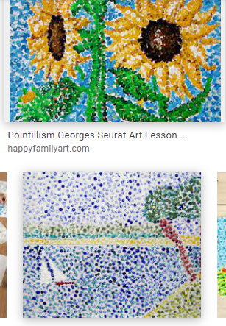
3 | Know about the work of a range of artists, craft makers and designers
Look at a variety of artists who look at these different concepts.
Form- white space, composition, and structural layout- 3D element.
Sculpture – artists who use clay
Texture- Artists who add texture to clay. Artists who use a variety of mediums to create texture.
Highlight key words- artist evaluation. For example, texture, sculpture,
Describe similarities and differences.

4 | In painting, use a variety of thick and thin brushes to produce lines and shapes, textures and patterns
Focus on texture, line, and patterns- Add things to the paint to change the texture, ie, sand, pva. Finger paintings, palette knife paintings, applying substantial amounts of paint, to create a thick texture. On mini canvases? Link this idea to animal’s fur or patterns/textures of leaves.
Carousel doing different activities.
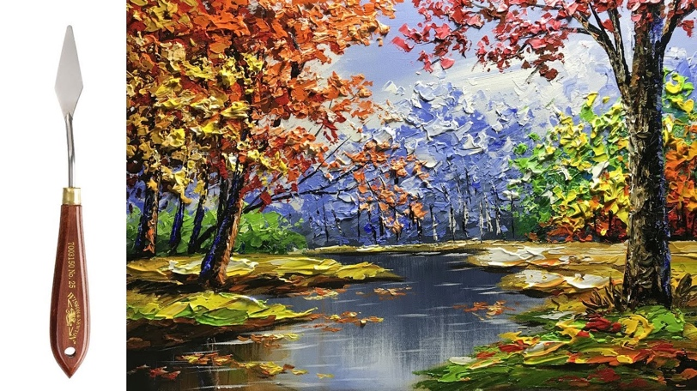

5 | In sculpture, create and combine shapes to make recognisable shapes
Look at form, think about the appropriate shapes for the leaves/petals etc. Experiment with drawing leaves.
Explore three dimensional shapes- can you link any of the 3D shapes to animals. What shape does a tiger's head look like? A sphere, triangular based pyramids for the ears ect.

6 | In sculpture, use techniques such as rolling, cutting, moulding, and carving
Discuss the Four Sculpture Types...Sculptures fall into four basic categories: molded, cast, carved or assembled. The media an artist uses for moulded sculptures include clay, wax, papier-Mache and plaster. Cast sculptures involve modelling the sculpture, then making a mould and casting it in a metal or other medium. Explain examples where scultures might be seen historically.
Practise using cutters, stencils, rollers, carving knives,
With playdough first – The class could make the play dough.

7 | Talk about the work of an artist, craft maker or designer.  How do the artist achieve a desired outcome? Does this link to their own work?
8 | Describe differences and similarities and make links to own work. What improvements could they make before their final piece?
 | Produce a 3d style drawing of the sculpture they are going to make using skills such as tone, texture, and depth to create the realisitic feel. Looking at tone and texture.
9 | Use and apply art and design techniques in using colour, patterns, texture, line, shape, form and space with range of materials
Then use clay to create a 3d sculpture which focuses on
Form- white space, composition, and structural layout- 3D element.
Sculpture – artists who use clay
Texture- Artists who add texture to clay.
Avoid misconceptions by making sure children understand the difference between a three-dimensional object and a two-dimensional object. Explain that their sculpture is to be an exact replica of a real plant/ succulent/ flower ext.
10 | I can Describe differences and similarities and make links to own work
 | Describe the similarities and differences between themselves and an artist who specialises in sculpture- preferably clay as it will be easier for the children to compare. You will need pictures based on an artist's work to compare to their own sculpture. Material may have been the same, the artist may have joined the clay together carefully using the water.

DT
I can Use basic principles of a healthy and varied diet to prepare dishes (Links to PSHE Lesson 4, 5 and 6)
I can understand where food comes from
I can Generate, develop, model, and communicate ideas through talking, drawing, templates, and ICT
Can Explore and evaluate a range of existing products eg home, school
Select from and use a wide range of materials and components (according to their characteristics) eg construction, textiles, and ingredients
Select from and use a wide range of tools and equipment to perform practical tasks eg cut, shape, join and finish

1 | I can Use basic principles of a healthy and varied diet to prepare dishes (Links to PSHE Lesson 4, 5 and 6)
To work in partners, one child is to create a plate of healthy food and create a balanced meal. The other is to create an unhealthy diet of poor food. Create a paper plate with a healthy balanced diet. Explain why it is important that we have variety in our diet to maintain a healthy lifestyle.
What examples of food can you think of that are healthy? Unhealthy?
Children can be creative and create and cut out all their different food types, thinking carefully about shape and texture.
Explain how we must eat at least 5 portions of a variety of fruit and vegetables every day. meals based on starchy foo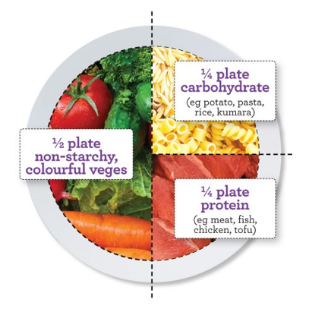ds, such as potatoes, bread, pasta and rice (choose wholegrain varieties when possible) some milk and dairy products or alternatives (choose low-fat options where you can)
Teacher- pick 5 examples to compare.
2 | I can understand where food comes from
Sort food’s that are natural, processed, healthy or unhealthy.
https://www.youtube.com/watch?v=5iJcLl0sHic

https://www.youtube.com/watch?v=9Opt06QF9WY

3 | Generate, develop, model, and communicate ideas through talking, drawing, templates, and ICT
Sugar paper- ideas what fruits would be used for different textures/shapes to make them look like animals.
Compare and decide what different fruits would be suitable for different animals.
Share ideas- creative as possible. Ask the children why they have chosen that fruit. How does it link to the colour/texture of the animal that they are wanting to create.
ICT create a shape I will use that relate to my animal
Paint2 app. To create shaped- fill them with the colours they will use
Construct the animal kebab using the ICT program,

4 | Explore and evaluate a range of existing products eg home, school
USe photographs of food to compare packaging, what looks healthy what doesn’t?
Children may way to think about what food they think is healthy and tasty.
What will they want to use withing their own work. It may be a good idea to compare foods,
writing reasons why children will or will not use that food in their healthy animal's kebab.
Explain why certain foods are healthy and that we need nutriets from healthy foods. Explain that some food has less
nutrients and more unhealthy fat and sugar
List the fruit that they will use. .
5 | Select from and use a wide range of materials and components (according to their characteristics) eg construction, textiles, and ingredients
Children will draw a picture of their animal in their sketchbooks and label each area in detail of what fruit they will use for each part of the animal and why?
Decide what fruit you will use and why? Explain to children that you might use a pineapple for its colour, texture.
Why is important that we choose healthy fruits for our fruit kebab? Why are we not making a chocolate kebab?
How does it make us feel when we make healthy life choices?
IS it better when we know wehre our food comes from? Does it help us make healthier life choices?

6 | Select from and use a wide range of tools and equipment to perform practical tasks eg cut, shape, join and finish
Explore a range of materials children could use to cut, join and stick.
Think about the structure what could they use to strengthen it?
Cocktail sticks. Children will need to begin at looking at the elements of structure.
What makes something structurally strong. How can you avoid any weak areas.
7 | Select from and use a wide range of tools and equipment to perform practical tasks eg cut, shape, join and finish
Use straws to create the structure of the animals. To start thinking about the structure.
To get children thinking about how they are going to make their fruit kebab strong a fit for purpose.
How will they get the fruit to stay on the stick/ cocktail sticks.
8 | Select from and use a wide range of materials and components (according to their characteristics) eg construction, textiles and ingredients
 | Produce a plan for an animal using a variety of fruit, using cocktail sticks to join and finish work. To provide structure and strength. To create a healthy desert for themselves.
9 | Select from and use a wide range of tools and equipment to perform practical tasks eg cut, shape, join and finish (Links to session 9 and 10 PSHE)
Talk about the process in a small evaluation. How did you make your animal kebab?
What was the first thing you had to consider?
Using appropriate fruit to represent your animals.
You had to consider that it would be tasty for the person eating it.
Consider using limited joins and finishes so that the product looks professional. List the tools that were used and ow they were used to achieve this affect.
10 | Select from and use a wide range of materials and components (according to their characteristics) eg construction, textiles and ingredients  Produce a animal using a variety of fruit, using cocktail sticks to join and finish work. To provide structure and strength. To create a healthy desert for themselves.
Children will need to consider all of the things they have learnt about what makes something strong.
What gives it structure? How they make and secure joints.
They will have to use minimal joins to create a product that is appealing.

PSHE
Staying Safe
To discuss the rules of the law.
To know how the emergency services help us and how to get their help.
To know ways to stay safe.
To keep ourselves and others safe.
Healthy Lifestyles
To know ways of keeping our body healthy including diet.
To discuss likes and dislikes.
To describe making the correct choices.
To show an understanding of personal hygiene.
To learn about good and not so good feelings.
E-Safety
To know ways to stay safe online.
To use the internet safely and respectfully.
To know how to keep their personal information private.
To discuss who they can talk to about any worries.

1  (E-Safety Summer 1) | I know ways to stay safe online and I can use the internet safely. (Computing Links- E-Safety)  I can discuss who I can talk to about any worries.
Begin the lesson by asking some questions to help children think about benefits and risks of the internet:
- What is the internet?
- How do we get onto the internet? (e.g. smartphones, smart TVs, tablets, computers)
- How can it help people (with children's input, create a list of benefits - e.g. find out information, keep in touch with people, play games - and other types of entertainment - shopping, selling things, donating (giving) to charities etc.)
- Is everything that we see or read on the internet true? (sometimes people make up stories and make them appear to real, sometimes people show pictures that have been changed, to make something or someone look better, for example, and sometimes people on the internet pretend to be something that they are not - for example, pretending they are children when they are actually adults.)
- How can we keep safe if we use the internet - now and as we get older?
- Tell us about any risks you've heard about the internet (give children time to think about this and share their ideas or experiences)
Explain that today we're going to be thinking about keeping safe when using the internet and that one of the risks of the internet is when people - children or grown-ups - share pictures of themselves or of others. Sometimes these can go to people that weren't meant to see them and we're going to find out how this can be harmful. Using Thinkuknow resources,watch Jessie and Friends Episode 2: Sharing Pictures. Discuss with the children what they have learnt from this video; can they write down 3 rules to share with another class.

1  (E-safety Summer 2) | I can explain simple guidance for using technology in different environments and settings e.g. accessing online technologies in public places and the home environment.  Health, Well-being and Lifestyle
Ask children to share what happens to them when they have been using technology for too long, eg sore eyes/ head, device runs out of battery or gets hot, parents get cross or your mood changes.
Ask the children to create a poster with tips for managing the amount of time you spend online. This could include the strategies used in the springboard activity as well as any they may already use at home, eg charging devices downstairs, not using technology an hour before bed time etc
Display the posters around the room, either on the wall or at each table. Run a class gallery to give children a chance to discuss each others ideas and learn more tips they can use as well.

2 | I can learn about good and not so good feelings
Start the session by asking children if they have seen your circle time object. Tell them you have looked everywhere but can’t find it. (Hide the object away before the lesson so that the children can’t see it). Is there anything else we could use as a circle time object. Take suggestions and agree on a different object to use.
Set up your circle time in the usual way with reminders about circle time ground rules. Using your new circle time object children can use the following prompt sentence stem to speak. (If children are still thinking they can say ‘I’m still thinking’):
“When I lost my XXXX I felt XXXX”
Discuss the following questions taking ideas as appropriate:
- Why is it upsetting to lose something?
- Have you ever lost anything but then found it later? How did it feel to find it again?
- Have you ever lost anything but never found it again? How did that feel? Were you able to replace the item?
Sometimes we lose things and find them again and sometimes we lose things forever. Read Harold loses Geoffery (SCARF)
On one half of a piece of paper draw a picture of yourself when you have lost something. Draw your face showing your emotions. Most children should also be able to write key words describing those emotions. On the other half of the paper draw yourself when you have found something. How does your face show your emotions now. Most children should be able to write key words to describe those emotions.
Ask pupils to share their drawing and key feelings words. At the end of the lesson you can ‘find’ the lost object and explain how you feel. End the session with, “When I find something I’ve lost I feel XXXX” How many different words can the class come up with? Pass the object round and a child says a word and passes the object on. If the next child can think of a different word they say it. If not they pass it on to the next child. At the end of the circle count-up how many words the class managed to think of.

3 | I know ways to stay safe and keep others safe
Using the website https://learning.nspcc.org.uk/media/1387/underwear-rule-resources-lesson-plan.pdf

Follow the lesson plan discussing appropriate and innapropriate touch and how we can keep ourselves safe. Ensure the children know who they can talk to if they have a concern.
4  (Healthy Living Week) | I can understand that the body gets energy from food, water and air (oxygen);  I can recognise that exercise and sleep are important parts of a healthy lifestyle.
- What sort of things do you think we can all do to stay healthy? [Have a good night’s sleep, eat healthy meals and snacks, do exercise every day, wash hands before eating meals and after going to the toilet; cleaning teeth before leaving for school etc.]
- Why is it important to have a good night’s sleep? [Because our bodies rest and grow when we’re asleep]
- Why is it important to exercise regularly? [To keep the body as fit as possible and to make us feel good]
- Why is it important to eat healthy food? [To give the body all the special things it needs to grow strong and healthy. NB: see 'I can eat a Rainbow' lesson plan for more in-depth work on healthy foods]
- Why is it important to have a wash and to brush our teeth? [To keep the body clean and reduce germs, to keep the teeth strong and healthy and help stop them decaying]

Divide a paper plate into 3 parts – split the plate into sections for what we need to keep alive, to keep healthy and to have as a treat. Use food catalogues for children to cut and stick food.
NB: Use the Healthy me! Teacher Answers and Information sheet for guidance if needed.

5  (Healthy Living Week) | I can recognise the importance of fruit and vegetables in their daily diet;  I can know that eating at least five portions of vegetables and fruit a day helps to maintain health.
Links to Science 7 and 8, to be taught together. Links to DT 1. Some links to music
Start the lesson with some key questions about healthy eating such as:
- What sort of foods do you think are healthy for our body?
- Are there any foods we need to avoid eating lots of?
Explain that different foods do different jobs for the body which is why we need to eat lots of different types of food to keep our body as healthy as possible. Play the song 'Different Foods'. Ask the children to listen out for the different foods that you discussed in the introduction and do the action that you learnt when you hear the different food groups mentioned. You might also like to teach the children the words to the chorus so that they can sing along. The words are provided for you to be displayed on your whiteboard.
https://www.coramlifeeducation.org.uk/scarf/lesson-plans/i-can-eat-a-rainbow

Can the children create rainbows using the different types of food we need as the colours. Could this be a rainbow of fruit? Children could then do food tasting.

6  (Healthy Living Week) | I can recognise which foods we need to eat more of and which we need to eat less of to be healthy
Links to Science 7 and 8, to be taught together. Links to DT session
Start the lesson by explaining that today we are going to talk about our likes and dislikes.
Set up a circle time in the usual way and remind the children of the circle time rules. There could be a circle time object to pass round. Perhaps a lunchbox?
Opening with circle time activity based on ‘I like bananas’ pass on to person next to you - if they like bananas they say the same but if they don’t they say a different fruit. Go all the way around the circle - this shows that pupils have different likes and dislikes.
Expand to talk about other foods:
- Which foods do they like/dislike?
- Which foods are healthy for us that we need to eat more of?
Refer now to Eatwell plate (IWB slide provided - see Resources needed area).
- What foods are less healthy that we need to eat less of?
Sometimes we need to choose things that are healthy to eat even though they may not be our favourite - ask children to think of one example each through a further circle.
Children to create a healthy lunchbox explaining why they have chosen each item.

7 | I can recognise emotions and physical feelings associated with feeling unsafe  I can identify people who can help them when they feel unsafe.
Start a discussion on feelings with some key questions:
How might we feel if:
- Your best friend comes round to play
- You’re going to a party
- You’re asked to tidy up your toys / games
- You can’t go out and play because it’s raining
- You’ve got no-one to play with at playtime
- Someone asks you to join in a game at playtime
- Other ideas
Explain that sometimes we can feel nervous, worried, anxious or scared about something, for example, going somewhere we haven’t been before. When we feel like this our body tells us that it’s having those feelings because things happen to our body which don’t normally happen. What things can happen to our body when we’re feeling nervous or worried? (prompt as necessary):
- Butterflies in the tummy
- Feeling hot
- Feeling sweaty
- Feeling sick
- Hands might shake
- Needing the toilet
- Going red in the face
- Other ideas

Can the children draw on a gingerbread man where their body shows us it is feeling nervous, anxious or worried. After this discussion go round the circle and ask children who they would talk to if they felt these feelings and if they were worried. Reinforce to the children that they can talk to other children and that if they feel like nobody is listening, who else could they turn to (could they wait until the person has finished, could they talk to someone else?) Children to write down who they would turn to if they felt these feelings – complete individually so that they all have their own network to turn to if feeling worried/anxious.
8 | I understand how diseases can spread  I can recognise and use simple strategies for preventing the spread of diseases.
 | Discuss the situation we have dealt with over the past few years and talk through the ways we have had to behave in order to curb the spread. Why is it important to keep up these hygiene routines in every day life? Put glitter on your hands and explain that these are the ‘germs’ and then shake hands with every child in the class- does every child now have glitter on their hands? Have a water bottle and pretend to sneeze – spray this and see what children felt the spray- explain again how germs can spread this easily. Can children think of any other diseases that spread? Any diseases that can’t spread? All children to create posters to have up around the classroom. Share story (Mrs Davis Usborne book) and explain that their posters needs to share key information. At the end assess one anothers posters and discuss what features are important and that they like from each poster. Discuss anything we don’t need on our poster. Show the NHS poster, Catch it Bin it Kill it.
9 | I can recognise that learning a new skill requires practice and the opportunity to fail, safely;
LINKS TO DT MAKING FRUIT ANIMAL (session 8)
What sort of things can you do now that you couldn’t when you were a baby?
Was it always easy to learn to do those things?
Which of the things that you can do now, which you couldn’t when you were younger, were the hardest to learn?
What did you have to do in order to make it easier? [Kept practicing, didn’t give up, learnt from mistakes, had help from other people etc]

Explain to the children that we are going to learn a new skill today, go through the skill (making fruit kebab animals) let the children have a go at it. After they have completed children to / write down a timeline of what they learnt as they went along. What stages did they go through? How did the children feel when they failed- did they give up? It is okay to fail. Can they make links to other times they have learnt a new skill e.g. riding a bike, writing their name, making slime etc.
10  (Can link to session 9) | I can demonstrate attentive listening skills;  I can suggest simple strategies for resolving conflict situations;  I can give and receive positive feedback, and experience how this makes me feel  I can recognise how a person's behaviour (including their own) can affect other people
LINKS TO DT SESSION FRUIT ANIMALS (session 8)
Set up a short role-play as follows:
Praise a child for something they have done e.g. “That was such a great story. You put a lot of effort into it. I liked the way you ended it.”
Explain that here you are giving support. Then say “Next time, to make it even better, you could add some more adjectives.” Explain that this time you were giving feedback to help the child with their next stage.
Ask the child how they felt when they heard the support and feedback.
Ask the individual child and also the class how they felt when they heard this happening.
- Who supports and encourages the children?
- Who in particular does this at school?
- How do we feel when we get support and encouragement?
- Who do they give support and encouragement to?
- How does it feel to give this as well as to get it?

After the last session give the children feedback on their fruit animals. Get the children to give other children feedback. How does it make them feel? It is okay not to get things right or ‘perfect’

Computing
Year 1 (CS)
I can begin to develop an understanding of algorithms
I can begin to understand that programs work by following instructions
I can create simple programs and begin to debug them
I can develop reasoning to predict the behaviour of simple program

Year 2 (CS)
I understand what algorithms are
I understand how algorithms are implemented as programs on digital devices
I understand that programs execute by following precise and unambiguous instructions
I use logical reasoning to predict the behaviour of simple programs
I can create and debug simple programs

E-Safety
Year 1
I can develop an understanding of how to use technology safely
I know where to go for help/support when I have concerns about content/contact on internet
Year 2
I can use technology safely and respectfully, keeping personal information private
I can identify where to go for help/support when concerned about content/contact on internet/other online technologies

1 | (E-safety) See PSHE Session 1 and 2 For each half term.
2 | I can follow instructions (Y1 Lesson 2)  I can give instructions
 | Explain to the children that they are going to be robots for the session. Give the children a set of simple, basic instructions – one step at a time, on the playground. For example, stand up, sit down, nod, wave, clap, 2 steps. Children to follow instructions and not do anything that they haven’t been asked. Link this to Bee-bots and explain that they have a set of instructions that we give them and that is all that they will follow. Get the children into pairs and ask them to create a set of 4 instructions their partner can follow. If they don’t yet know left/right encourage to practice but give them the option to point when they say turn. To end the session teacher give the bee-bot some secret instructions and see if the children can guess what they were.
3 | I can compare forwards and backwards (N/S) (Geography) (Y1 lesson 3)  I can start sequence from the same place  I can predict the outcome of a sequence
 | Use the slide on teach computing to support showing the children the bee-bot instructions. Explain what each button represents and esnure the children know that they need to clear the sequence before starting a new one. Using the beebots show the slides for the children to have a go at moving forwards and backwards (Link in the geography terminology N/S)
4 | I can compare left and right turns (E/W) (Geography) (Y1 lesson 4)  I can experiment with move and turn commands  I can predict the outcome of a sequence
 | This activity is about learners trying out programming through trial and error. The children should use the maps from the resources section and have a go at using the correct terminology (geography) and see if they can get their robot to reach certain places.Emphasise that the turn command just turns the robot they will still need to use forwards and backwards to make the robot move. Use the resources/planning materials from teach computing to ensure correct terminology is used.
5 | I can use the same instructions to create different algorithms (y2 lesson 2)  I can use an algorithm to program a sequence on a floor robot  I can show the difference in outcomes between two sequences that consist of the same commands  I can predict
 | Explain how important it is to give robots a set of instructions that are in order. Explain that the set of instructions the children gave the robots in the previous session are called algorithms. An algorithm is a precise set of instructions given to a robot/computer. (Beebots have computers inside them) Child are to think of 4 different set of algorithms they can test on their bee-bot. Prior to testing it can they predict where their robot should end up on the mat. Use sheets provided in NCCE teach computing resources. They need to use all buttons on the bee-bot and remember to press clear before they complete a new set of instructions.
6 and 7 | I can explain the choices I made for my mat design (y2 lesson 4) (Geography links __)  I can identify different routes around my mat  I can test my mat to make sure that it is usable
Children should think of 5 key places they know in Blackpool linked to human features that they have learnt about in Geography. Children to discuss how they could create their map linked to Blackpool- what images would they need. Discuss ideas in pairs. Hand out mats (resources in teach computing) and get the children to pick 5 sqaures that they could add their images/links to Blackpool. They need to think about how the bee-bot will move around and if they are putting it in an accessible place. (The mat is formed using 2 A3 sheets of paper)

For the second session, ask the children to think about different routes they could create moving around Blackpool. Can they plan these routes and predict what might happen. Where will they place their start square? T check mats are viable ready to move onto obstacles. Ask the children to think of possible obstacles we may come across (road blocks etc.) Can they use building blocks to place these onto the map for the children to test out first. Ensure children mark these down on their maps to use next time.
7 and 8 | I can explain what my algorithm should achieve (y2 lesson 5) (Geography links __)  I can create an algorithm to meet my goal  I can use my algorithm to create a program
 | Learners need to discuss the routes they want to send their robots on through their mat. They need to draw the algorithms to show these routes- use pictures to show these commands and then these can be used in the program later. Use a paper bot to test out their route before they use the beebot. Children need to start their robot on their start square and ensure that they look at the sequence of commands that they have drawn to program their robot. To keep track work in pairs and ensure each command is ticked off as it is entered into the robot. If the robot does not move where they want it to, get the children to clear the robot and start again. How can they fix their programme if it isn’t working? If something didn’t go right with their programming explain to the children that we can ‘debug’ which is when we fix a programme- this happens all the time with programmers. Ask the children what they have learnt this session and what they felt most confident in.
9 and 10 | I can test and debug each part of the program (y2 lesson 6)  I can plan algorithms for different parts of a task  I can put together the different parts of my program
 | Explain that when programmers create programmes, they design a part, test it, alter it and then when it works move onto the next section. See session 6 on teach computing to work with the slides that explain how they can. Children to plan how to get to one square, test it and then make sure it works. Then children plan to get to another square, test it, ensure it works. Once they know that it does work, children to then put the two sections together. This is a larger algorithm which means it is more complicated (hence the reason we plan a section at a time) The 2 sections need to flow together so children need to make sure if any section goes wrong they clear the robot but make sure that it goes back to where it needs to go on the squares (unless they are going back to the start) Between the two sections when programming children should use the pause button to show that they have combined the two different routes. Children to summarise what they have learnt and write an explanation on how to create routes for robots or maybe a set of instructions.

