Lower Key Stage Two Newsletter

It has been a fantastic half term and we can’t quite believe we only have one half term left.
Thank you very much to everyone who came to support us on Sports Day. We had a brilliant time!

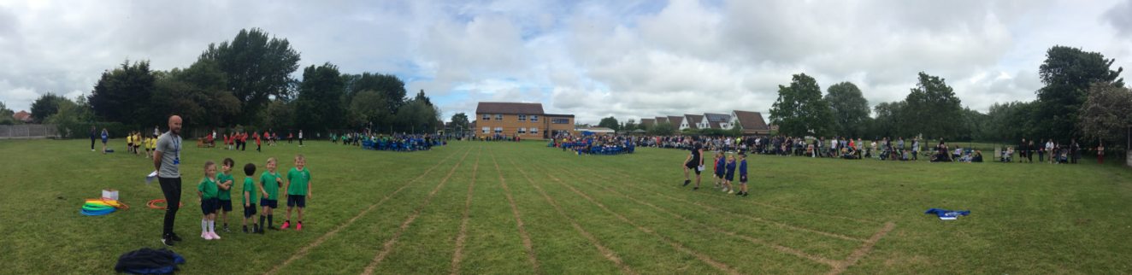

We ended our half term with a wonderful Queen’s Jubilee celebration. All of the outfits were fantastic and the children enjoyed performing their songs to the whole school.

Special News
A huge well done to our new Sports Council members
Kestrels - Charlie and Annabel
Owls – Harry P and Alex
Doves – Hunter and Evie E
Well done everyone!

What have we been learning?
This half term, we have thoroughly enjoyed learning about Ancient Greece. We have been busy writing our own myths and learning about the Greek Gods and Goddesses. We have also been mastering money, decimals and measure in Maths. We are so impressed with the amazing progress everyone has made with their times tables this half term. In Science, we have been finding out what plants need to survive and we have been learning about Europe in Geography.

What are we learning about next half term?
Next half term, we will be designing and making our own Greek temple. In Maths, we will be developing our knowledge of time, shape and statistics. We will be learning about the Greek Olympics and writing our own debate about Athens vs Sparta. Also, Miss Clarke will be returning to school after half term and will be covering PPA across all three LKS2 classes.

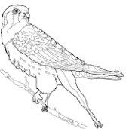
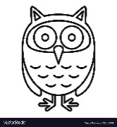

A few reminders...
Homework
Please make sure you look at our home learning pages every Friday and complete the homework that has been set. It is incredibly important that you continue to read at home every day and log this in your reading journal. Please let us know if you need any passwords or log in details.
Useful websites
TTRS
Maths Frame
www.topmarks.co.uk (hit the button)
IDL
www.oxfordowl.co.uk

Playground Equipment
The playground equipment should not be used before or after school.

Uniform
Please make sure all items of uniform (including PE kit) are named. The children will need hats and sun cream as the weather starts to warm up.

Library
Please return your library books. We enjoy visiting the library every week.

Dates for your diary:
Monday 6th June – Return to School
Week 14th June – Year 4 Times Table Check
Friday 17th June – Non – Uniform Day
Monday 20th June – Class Photographs
Thursday 30th June – Summer Fair
Friday 1st July – School closed for additional bank holiday.
Week 4th July – Transition to new classes

If you have any questions, please do not hesitate to come and see us.
We hope you have a wonderful half term break!
Miss Wilson, Mrs Shepherd and Miss Clarkson
