Welcome to Parrots
2021-2022
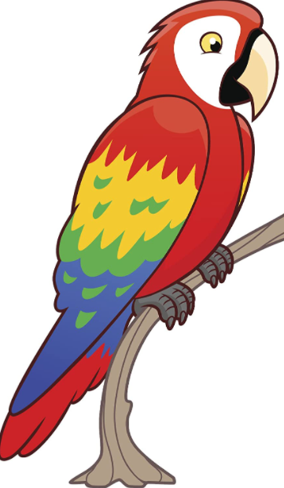
Information for Parents
Welcome to Key Stage 1
The KS1 Team
Mr Boyd – Robins
Mrs Davis – Parrots
Mrs Oddy/Miss Howell- Herons
Learning Support Assistant’s (LSA)
Mrs Noctor - Robins
Mrs Moss - Herons
Miss Hutchinson- Parrots
Daily Routine
In September the children will come into school at 8.50am. The children come in by themselves using Parrots class door via the main school yard. Any pupils who arrive late should report to the school office.
The children will have a morning and afternoon break. The children will have their snack after afternoon break time. The children will also be able to have milk at this time, if they are on the milk list.
12:00-1:00pm: Lunch time.
School finishes at 3:30pm. If no one arrives to collect your child by 3:40pm, I will take them to the main office and contact home.
I will be at the door both before and after school to enable you to pass on any important messages. If you would like to talk privately or in more detail please do not hesitate to contact me via my email address.
Curriculum
The children will do English, Maths, Phonics and Handwriting every day, along with Reading, Spelling, Punctuation and Grammar (SPAG).
During the Autumn term, our PE day will be on a Thursday. Please make sure that your child comes to school wearing their school PE uniform. PE may be outdoors so please take this into consideration!
In KS1, our Topic changes every term and it is through our topic that we also teach other subjects. In order for you to know what we are doing, we will post regularly on our class blog which can be accessed via the school website. Medium term plans can also be found on the school website for Autumn Term.
Throughout the year we also hope to go on a variety of exciting school trips. Our school trips will take place in the Spring and Summer term. Information and costing will be provided in the near future.

Home Learning
Daily reading- Reading every day is one of the most important ways you can support your child’s learning. Reading books will be sent home and changed weekly but please ensure they come into school every day. Oxford owls is also a great resource to use at home if you get through your reading book from school.
IDL –We will continue to use our IDL programme in school. We encourage the children to log on twice a week at home. All children will be given their IDL log in details. Please do not hesitate to ask me if you need any help logging on.
Weekly spellings - The children will be asked to learn a set of spellings on a weekly basis. The children will be given a set of spellings every Friday, with tests the following Friday. These words are based on our phonics learning and common exception words for the term. Weekly spellings will be uploaded onto our home learning page.
Homework - In KS1 homework will be set on a Friday and must be completed by the following Wednesday. Homework will be uploaded onto our home learning page and we will use Education City as well as other homework. All children have their own log in, please ask if you need any help. Our homework is based on the learning that has been taking place in school.
https://carletongreen.lancs.sch.uk/home-learning
https://go.educationcity.com/
Expectations
At Carleton Green our expectations of behaviour are promoted through the Carleton Code. All pupils have their own passport and these will continue to be used to promote good behaviour and learning.
The Carleton Code
Confident – putting their hand up, trying something new.
Achieve full potential – improving their work by following my advice and completing next steps of learning.
Responsible and reliable – looking after their own belongings, listening to instructions.
Lifelong learner – producing work at home, bringing things in to support learning.
Energetic and healthy – being active at break times, bringing healthy snacks.
Trustworthy – telling the truth.
Organised – having their reading book at school every day, handing in homework on time.
Nurturing – looking after their friends.
In the classroom we operate a three strike system. Anyone misbehaving will have their name written on a whiteboard. If a child then has two strikes next to their name, due to continued misbehaviour, they will be sent to another classroom/kept in at a playtime as a consequence.
Every week I will choose a ‘Star of the week’, for someone who has really stood out all week.
We will continue to celebrate ‘writer of the half term’ and ‘mathematician of the half term’. Work will be displayed on the main school corridor to celebrate these achievements.
Uniform
All children must now have the new PE uniform. Please see our school website for all of the details about what your child needs to wear for PE.
Please make sure all uniform is clearly labelled.
All children must wear black smart shoes. We ask that children do not wear jewellery, apart from a single watch and stud earrings (earrings need to be removed or covered with plasters on PE days). The children should not wear nail varnish.
Medical
If your child is unwell and cannot attend school, please contact school as soon as possible on the day of an absence. Following any vomiting children should not return to school until 48 hours after last being sick.
It is important that you check your child’s hair regularly.
If you need school to give your child any medicine you must complete a medical form, available from the office. The medicine must have a name label clearly visible.
Please let school know about any changes to your child’s ongoing medical needs or any newly diagnosed medical conditions.
General
Please inform the school office if there are any changes to your personal details (e.g. different phone number, change of address).
Important messages are sent out via text message or email. Please let me know if you are not receiving them or if you require a paper copy of school newsletters.
All snacks need to be healthy and water only in water bottles. Please make sure water bottles have a name label on.
The children are asked not to bring toys into school.
Please continue to check our school website, class blog and home learning page on a regular basis.

Please do not hesitate to come and see me if you would like to discuss anything, my door is always open.
I do hope this has been helpful to you.
Mrs Davis
e.davis@carletongreen.lancs.sch.uk

