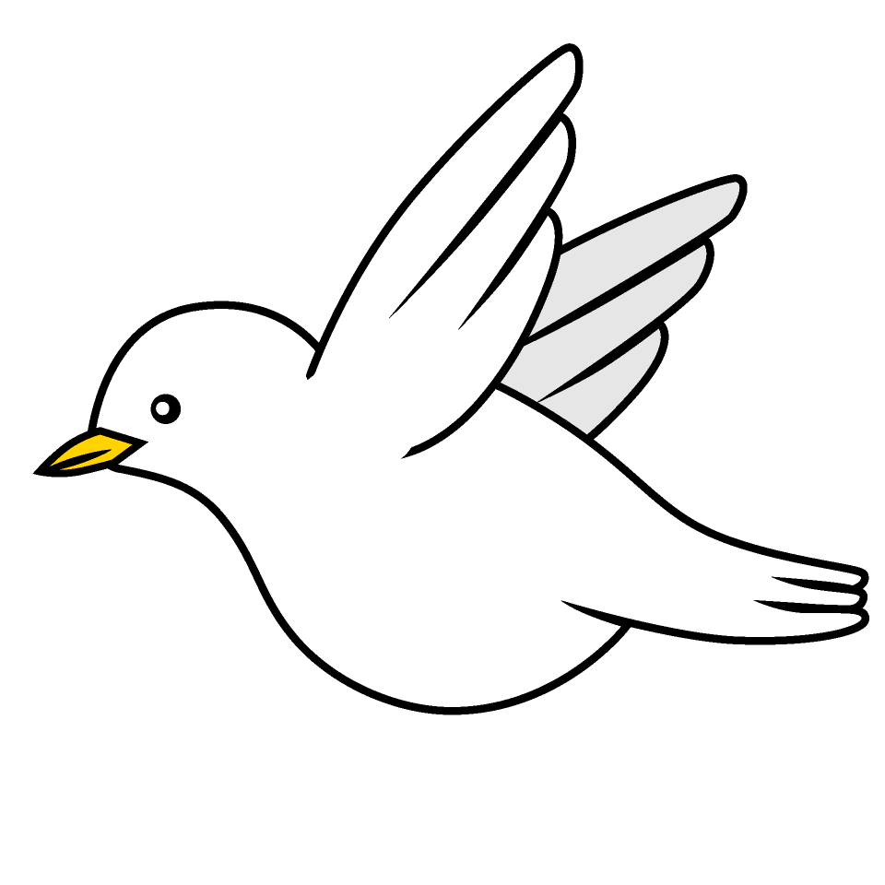
Welcome to Doves
2022-2023
Information for Parents
Welcome to Key Stage 2
The Y3/4 Team
Mr Boyd – Doves
Miss Wilson – Owls
Mrs Shepherd – Kestrels
Learning Support Assistant’s (LSA)
Mrs Macdonald - Doves
Mrs Navruz - Owls
Mrs Soneya - Kestrels
Daily Routine
In September the children will come into school at 8.55am. The children come in by themselves using the door off the EYFS playground. Any pupils who arrive late should report to the school office.
During the morning children will have time for snack and/or toast and also a morning break.
12:00-1:00pm: Lunch time.
School finishes at 3:30pm. If no one arrives to collect your child by 3:40pm, I will take them to the main office and contact home.
I will be at the door both before and after school to enable you to pass on any important messages. If you would like to talk privately or in more detail please do not hesitate to contact me via email.
Curriculum
The children will do English, Maths, and Handwriting every day, along with Reading, Spelling, Punctuation and Grammar (SPAG). This will be supplemented with the other foundations subjects taught in the primary curriculum. The children will also be learning a modern foreign language and at Carleton Green that is French.
Our Topic changes every term and it is through our topic that we also teach other subjects. The topic for the Autumn term is ‘Exciting Earth’.

Home Learning
Daily reading- Reading every day is one of the most important ways you can support your child’s learning. Please ensure you write in your child’s reading record when you have listened to them read or read to them. You can also access Oxford Owl at home for other reading activities.
IDL –We will continue to use our IDL programme in school. We encourage the children to log on twice a week at home. All children will be given their IDL log in details. Please do not hesitate to ask me if you need any help logging on.
TTRS - Please access this as often as you can at home, it will form part of your homework.
Weekly spellings - The children will be asked to learn a set of spellings on a weekly basis. The children will be given a set of spellings every Friday, with tests the following Friday. These words are based on our phonics learning. Weekly spellings will be uploaded onto our home learning page.
Homework - Homework will be set on a Friday and must be completed by the following Wednesday. Homework will be uploaded onto our home learning page. We will continue to use Education City for homework and all children have their own log in, please ask if you need any help. Our homework is based on the learning that has been taking place in school.
https://carletongreen.lancs.sch.uk/home-learning
https://go.educationcity.com/
Expectations
At Carleton Green our expectations of behaviour are promoted through the Carleton Code. All pupils have their own passport and these will continue to be used to promote good behaviour and learning.
The Carleton Code
Confident – putting their hand up, trying something new.
Achieve full potential – improving their work by following my advice and completing next steps of learning.
Responsible and reliable – looking after their own belongings, listening to instructions.
Lifelong learner – producing work at home, bringing things in to support learning.
Energetic and healthy – being active at break times, bringing healthy snacks.
Trustworthy – telling the truth.
Organised – having their reading book at school every day, handing in homework on time.
Nurturing – looking after their friends.
In the classroom we operate a three strike system. Anyone misbehaving will have their name written on a whiteboard. If a child has three strikes next to their name, due to continued misbehaviour, they will be kept in at a playtime as a consequence.
Every week I will choose a ‘Star of the week’, for someone who has really stood out all week.
Uniform
Please make sure all uniform is clearly labelled.
All children must wear black smart shoes. We ask that children do not wear jewellery, apart from a single watch and stud earrings (earrings need to be removed or covered with plasters on PE days). The children should not wear nail varnish.
Medical
If your child is unwell and cannot attend school, please contact school as soon as possible on the day of an absence. Following any vomiting children should not return to school until 48 hours after last being sick.
It is important that you check your child’s hair regularly.
If you need school to give your child any medicine you must complete a medical form, available from the office. The medicine must have a name label clearly visible.
Please let school know about any changes to your child’s ongoing medical needs or any newly diagnosed medical conditions.
General
Please inform the school office if there are any changes to your personal details (e.g. different phone number, change of address).
Important messages are sent out via text message or email. Please let me know if you are not receiving them or if you require a paper copy of school newsletters.
All snacks need to be healthy and water only in water bottles. Please make sure water bottles have a name label on.
The children are asked not to bring toys into school.
Please continue to check our school website and home learning page on a regular basis.

Please do not hesitate to come and see me if you would like to discuss anything, my door is always open.
I do hope this has been helpful to you.
Mr Boyd
s.boyd@carletongreen.lancs.sch.uk

