Spellings Doves Date: 10.12.21 To be tested: 17.12.21
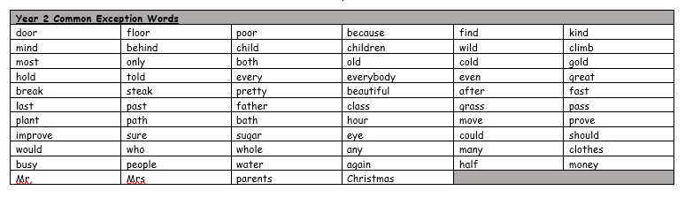
Group 1
Word
hopped
skipped
hissing
carrying
enjoying
hugged
talking

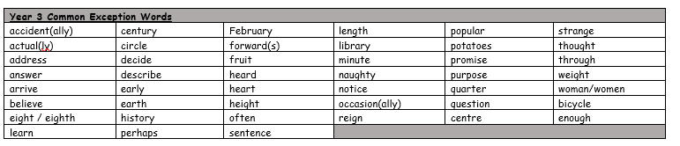

Spellings Doves Date: 10.12.21 To be tested: 17.12.21
Group 2
Word
gardener
beginning
limited
forgetting
preferred
slipped
tripped
ripped

Spellings Doves Date: 10.12.21 To be tested: 17.12.21
Group 3
Word
committed
beginning
limited
preferred
gardening
occurred
beginner
forgotten
