Spellings Doves Date: 10.6.22 To be tested: 17.6.22
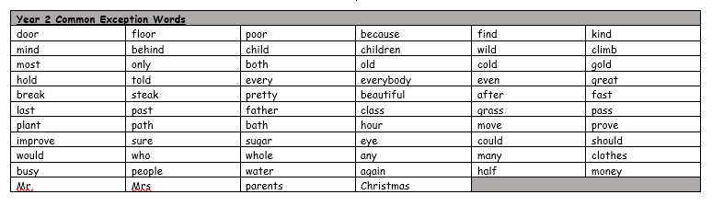
Group 1
Word
could
asked
again
some
our
people

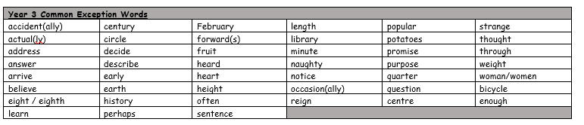
You will be tested on these words for the next few weeks. Please make sure you practise them at home.

Spellings Doves Date: 10.6.22 To be tested: 17.6.22
Group 2
Word
sadly
usually
finally
happily
angrily
basically

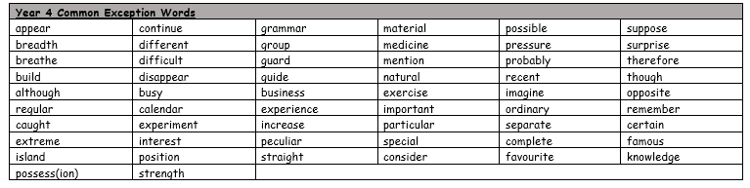

Spellings Doves Date: 10.6.22 To be tested: 17.6.22
Group 3
Word
completely
dramatically
gently
comfortably
temporarily
scientifically

