Spellings Doves Date: 10.9.21 To be tested: 17.9.21
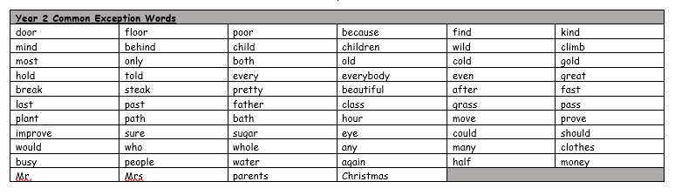
Group 1
Word
would
should
water
because
child
busy
every
again

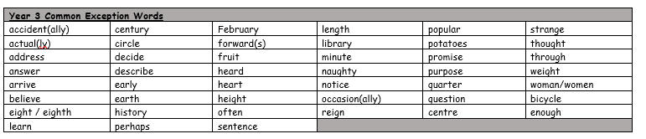

Spellings Doves Date: 10.9.21 To be tested: 17.9.21
Group 2
Word
answer
popular
often
learn
minute
enough
strange
actual

Spellings Doves Date: 10.9.21 To be tested: 17.9.21
Group 3
Word
appear
natural
famous
certain
island
busy
group
recent
