Spellings Doves Date: 12.11.21 To be tested: 19.11.21
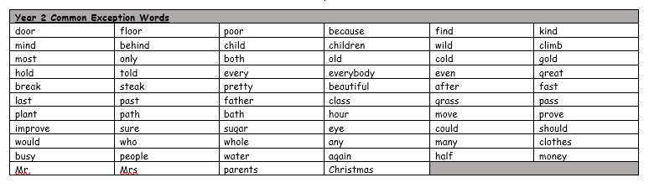
Group 1
Word
redo
replay
return
mistake
rebuild
young
touch

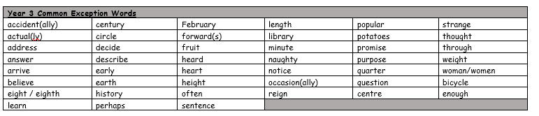

Spellings Doves Date: 12.11.21 To be tested: 19.11.21
Group 2
Word
mistake
misbehave
return
reread
rewrite
young
touch
trouble

Spellings Doves Date: 12.11.21 To be tested: 19.11.21
Group 3
Word
recalculate
reappear
misbehave
rewrite
mistake
misunderstand
trouble
country
