Spellings Doves Date: 13.5.22 To be tested: 20.5.22
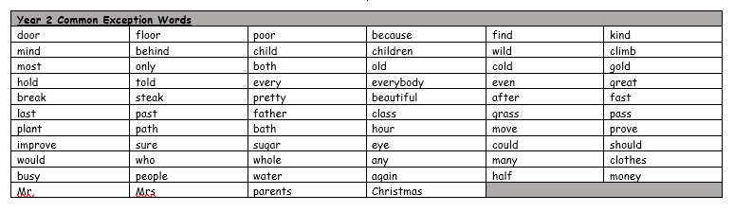
Group 1
Word
when
where
said
they
there
think

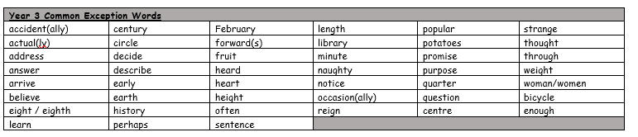
You will be tested on these words for the next few weeks. Please make sure you practise them at home.

Spellings Doves Date: 13.5.22 To be tested: 20.5.22
Group 2
Word
famous
dangerous
envious
nervous
poisonous
serious

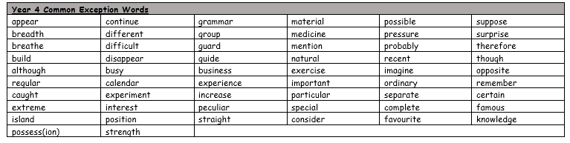

Spellings Doves Date: 6.5.22 To be tested: 13.5.22
Group 3
Word
courageous
adventurous
spacious
marvellous
mountainous
ambitious

