Spellings Doves Date: 14.1.22 To be tested: 21.1.22
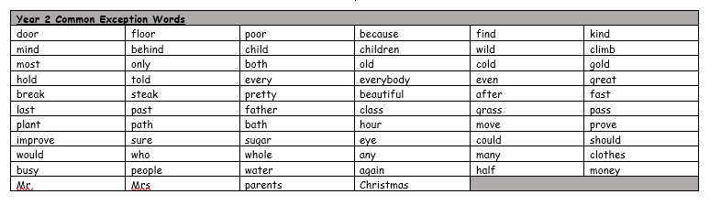
Group 1
Word
nature
picture
mixture
feature
capture
teacher
catcher

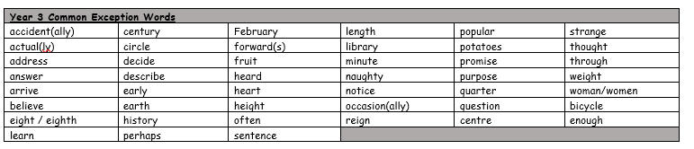

Spellings Doves Date: 14.1.22 To be tested: 21.1.22
Group 2
Word
creature
capture
fixture
mixture
vulture
sculpture
butcher
voucher

Spellings Doves Date: 14.1.22 To be tested: 21.1.22
Group 3
Word
adventure
furniture
moisture
structure
temperature
miniature
departure
gesture
