Spellings Doves Date: 15.10.21 To be tested: 22.10.21
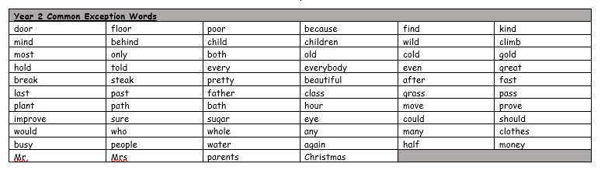
Group 1
Word
here
hear
great
grate
blue
blew
break
brake

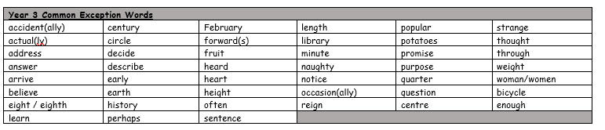

Spellings Doves Date: 15.10.21 To be tested: 22.10.21
Group 2
Word
break
brake
seen
scene
eight
ate
fair
fare

Spellings Doves Date: 15.10.21 To be tested: 22.10.21
Group 3
Word
peace
piece
weather
whether
fair
fare
seen
scene
