Spellings Doves Date: 17.9.21 To be tested: 24.9.21
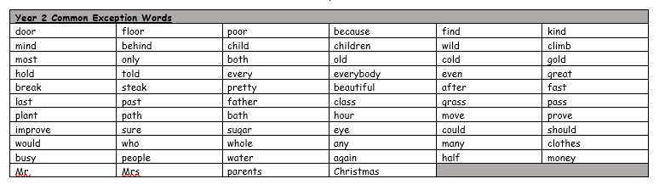
Group 1
Word
unhappy
dislike
untie
unfair
Egypt
tomb
ancient
used

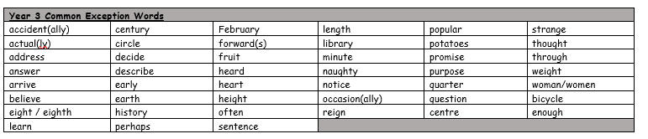

Spellings Doves Date: 17.9.21 To be tested: 24.9.21
Group 2
Word
unlucky
unkind
disagree
discomfort
used
tomb
Egypt
ancient

Spellings Doves Date: 17.9.21 To be tested: 24.9.21
Group 3
Word
disappoint
dishonest
unlucky
disobey
used
tomb
ancient
Egyptian
