Spellings Doves Date: 19.11.21 To be tested: 26.11.21
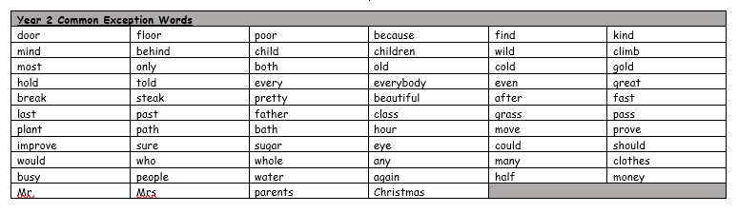
Group 1
Word
gym
myth
chef
mystery
about
always
any

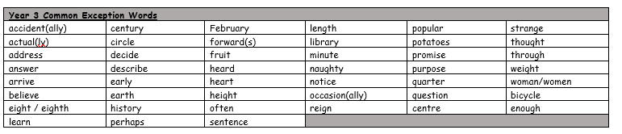

Spellings Doves Date: 19.11.21 To be tested: 26.11.21
Group 2
Word
chef
machine
system
myth
gymnast
mystery
discovery

Spellings Doves Date: 19.11.21 To be tested: 26.11.21
Group 3
Word
mystery
mythical
system
gymnastics
brochure
parachute
discoveries
investigate
