Spellings Doves Date: 1.10.21 To be tested: 8.10.21
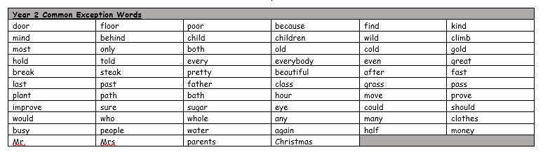
Group 1
Word
they
grey
vein
prey
eight
very
other

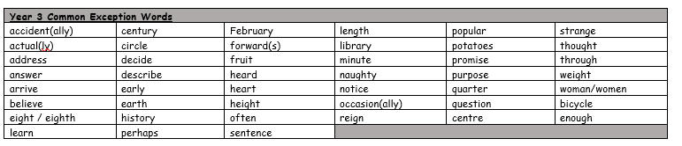

Spellings Doves Date: 1.10.21 To be tested: 8.10.21
Group 2
Word
weight
obey
vein
eight
sleigh
always
many
very

Spellings Doves Date: 1.10.21 To be tested: 8.10.21
Group 3
Word
neighbour
reign
weightless
eighteen
reindeer
surprise
another
