Spellings Doves Date: 20.5.22 To be tested: 27.5.22
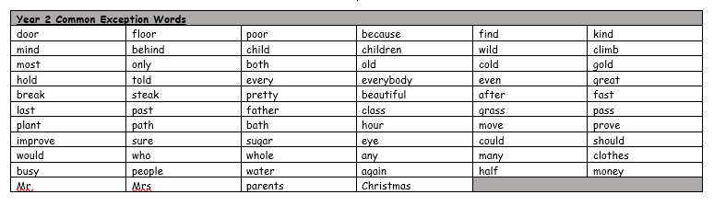
Group 1
Word
when
where
said
they
there
think

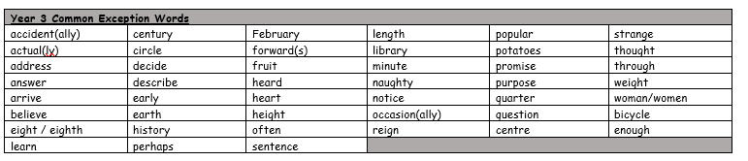
You will be tested on these words for the next few weeks. Please make sure you practise them at home.

Spellings Doves Date: 20.5.22 To be tested: 27.5.22
Group 2
Word
unlock
reattach
unfinished
automatic
submerge
discover

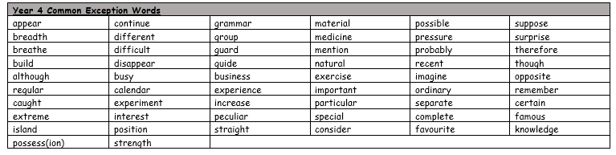

Spellings Doves Date: 20.5.22 To be tested: 27.5.22
Group 3
Word
disappear
overbalanced
decompose
disobey
recalculate
misunderstand

