Spellings Doves Date: 21.1.22 To be tested: 28.1.22
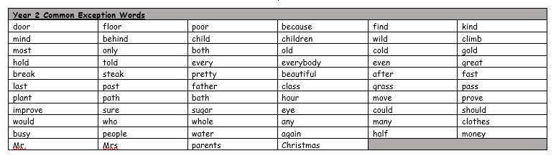
Group 1
Word
ball
bawl
seen
scene
mail
male

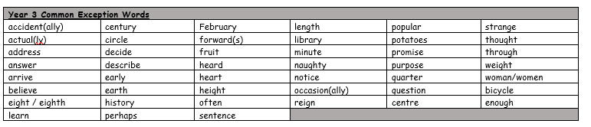

Spellings Doves Date: 21.1.22 To be tested: 28.1.22
Group 2
Word
mail
male
ball
bawl
grown
groan
here
hear

Spellings Doves Date: 21.1.22 To be tested: 28.1.22
Group 3
Word
there
their
heel
he’ll
heal
plain
plane
