Spellings Doves Date: 22.4.22 To be tested: 29.4.22
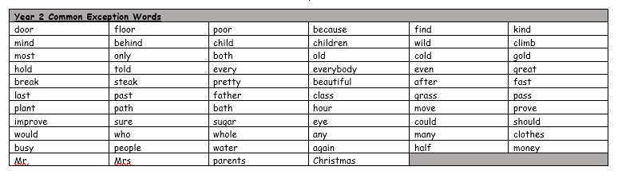
Group 1
Word
when
where
said
they
there
think

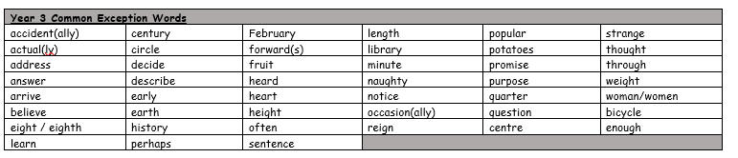
You will be tested on these words for the next few weeks. Please make sure you practise them at home.

Spellings Doves Date: 22.4.22 To be tested: 29.4.22
Group 2
Word
purpose
thought
heard
reign
weight
centre

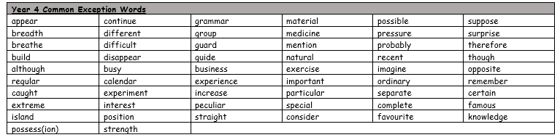

Spellings Doves Date: 22.4.22 To be tested: 29.4.22
Group 3
Word
breath
experience
knowledge
disappear
though
grammar

