Spellings Doves Date: 24.9.21 To be tested: 1.10.21
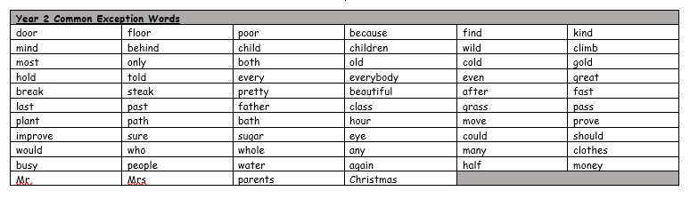
Group 1
Word
measure
treasure
closure
picture
nature
tunnel
explorer
danger

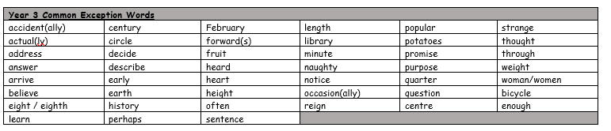

Spellings Doves Date: 24.9.21 To be tested: 1.10.21
Group 2
Word
enclosure
pleasure
exposure
creature
picture
treasure
tunnel
explorer

Spellings Doves Date: 24.9.21 To be tested: 1.10.21
Group 3
Word
enclosure
pleasure
exposure
adventure
leisure
treasure
explorer
mystery
