Spellings Doves Date: 25.2.22 To be tested: 4.3.22
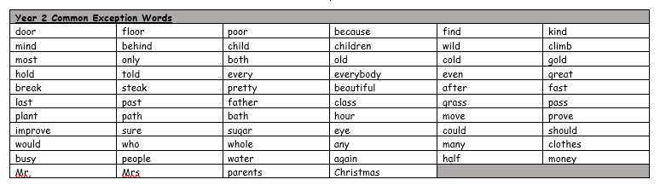
Group 1
Word
town
city
different
change
small
large

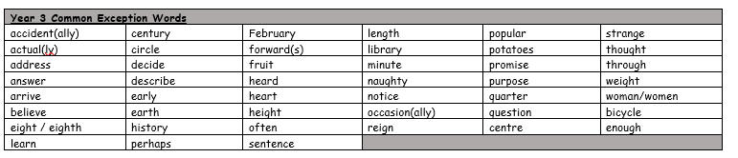

Spellings Doves Date: 25.2.22 To be tested: 4.3.22
Group 2
Word
interact
anticlockwise
antisocial
intercity
interrupt
antihero

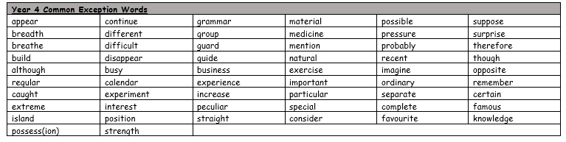

Spellings Doves Date: 25.2.22 To be tested: 4.3.22
Group 3
Word
antibiotic
antihero
international
intergalactic
interrupt
intercept

