Spellings Doves Date: 26.11.21 To be tested: 3.12.21
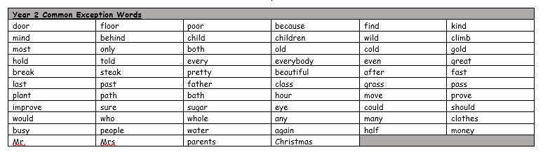
Group 1
Word
could
should
would
thought
again
behind
before

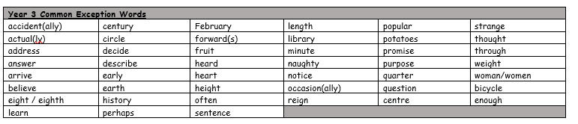

Spellings Doves Date: 26.11.21 To be tested: 3.12.21
Group 2
Word
thought
sentence
enough
heard
describe
believe
question
Strange

Spellings Doves Date: 26.11.21 To be tested: 3.12.21
Group 3
Word
important
medicine
extreme
mention
different
possible
suppose
though
